 | MLS – HEALTH & NUTRITION RESEARCH (MLSHNR)  http://mlsjournals.com/Health&nutritionrsearch-Journal  ISSN: 2603-5820 | 
(2026) MLS-Health & Nutrition Research, 5(1). 113-125.doi.org/10.60134/mlshn.v5n1.4803

Footprint Analysis in Children Aged 5 to 11 Years: A Study in the City of Quito

Análisis de la Huella Plantar en Niños de 5 a 11 Años: Estudio en la Ciudad de Quito

Nancy Guadalupe Aguirre Vega
Instituto Superior Tecnológico Universitario Libertad, Spain (nancy.16142@gmail.com) (https://orcid.org/0009-0004-1214-9299)
Jessenia Marilin Freire Montenegro
Instituto Superior Tecnológico Universitario Libertad, Spain (drafreirejess94@gmail.com) (https://orcid.org/0009-0005-9567-1548)
Amira Belkys Carrillo Valencia
Instituto Superior Tecnológico Universitario Libertad, Spain ( abc-valencia1@hotmail.com) (https://orcid.org/0009-0004-4441-5862)

Manuscript information:

Recibido/Received:27/03/26
Revisado/Reviewed: 06/05/26
Aceptado/Accepted: 16/06/26
 | Abstract
Keywords:  plantar footprint, pediatric population, cavus foot, pedigraphy. | Introduction: Footprint and posture analysis in children is a highly relevant topic in podiatry and biomechanics, as it allows for the identification of alterations that can directly influence motor development, gait, and consequently, future quality of life. In the city of Quito, there are no previous studies that specifically address this issue, highlighting the need to generate local data to understand the behavior of children's feet in this population and, in turn, contribute evidence to the national scientific community. Methods: This study was designed as a descriptive and exploratory investigation with a quantitative design, aimed at collecting data that explain variations in gait pattern through the application of pedigraphic tests in children between 5 and 11 years old. Results: The results show that 70 participants presented with cavus feet, representing 66.67% of the sample; while 20 children, equivalent to 19.04%, exhibited flat feet. Fifteen participants, representing 14.28%, presented with a normal or neutral foot. Discussion These findings reflect a marked predominance of cavus feet within the studied population, followed by a smaller percentage of flat feet, highlighting particular morphological patterns that require greater professional and scientific attention. Taken together, these results underscore the importance of continuing to investigate and promote frequent podiatric evaluations in children to identify early alterations and guide timely interventions.
 | RESUMEN
Palabras clave:  huella plantar, población pediátrica, pie cavo, pedigrafía | Introducción: El análisis de la huella y la postura del pie en niños es un tema de gran relevancia dentro de la podología y la biomecánica, ya que permite identificar alteraciones que pueden influir directamente en el desarrollo motor, la marcha y, en consecuencia, en la calidad de vida futura. En la ciudad de Quito no existen estudios previos que aborden esta problemática de manera específica, lo que resalta la necesidad de generar información local que permita comprender el comportamiento del pie infantil en esta población y, a su vez, aportar evidencia para la comunidad científica nacional. Método: El estudio realizado se planteó como una investigación de tipo descriptivo y exploratorio, con un diseño cuantitativo, orientado a recopilar datos que expliquen las variaciones en la forma de la pisada mediante la aplicación de pruebas de radiografías en niños entre 5 y 11 años. Resultados: Los resultados obtenidos muestran que 70 participantes presentaron pie cavo, lo que representa el 66.67% de la muestra; mientras que 20 niños, equivalentes al 19.04%, evidenciaron pie plano; y 15 participantes, correspondientes al 14.28%, presentaron un pie normal o neutro. Discusión: Estos hallazgos reflejan una marcada predominancia del pie cavo dentro de la población estudiada, seguido por un porcentaje menor de pie plano, lo que evidencia patrones morfológicos particulares que requieren mayor atención profesional y científica. En conjunto, estos resultados subrayan la importancia de continuar investigando y promoviendo evaluaciones podológicas infantiles frecuentes para identificar alteraciones tempranas y orientar intervenciones oportunas.

Introduction
Foot development during childhood is significant from both a clinical and biomechanical perspective, since between the ages of 5 and 11, structures essential for locomotion, body weight support, and postural stability become established. This growth phase is a critical time in the development of the arch of the foot and, consequently, in the prevention of conditions such as flat feet or high arches, which could lead to orthopedic and functional complications later in life.
Internationally, numerous studies have examined the association between foot prints and body posture (1), evaluating the relationship between foot prints and body posture in a school population using the Hernández Corvo Index (IHC) and the Portland State University (PSU) method. They reported that 10% of the students had flat feet and found significant differences in posture based on gender. They also identified a moderate correlation between body mass index (BMI) and shoulder-to-waist ratio (1). In another study, Stefan et al. noted that lower levels of physical activity are associated with increases in plantar pressure, as well as longer contact time and higher peak and average pressure values. These findings indicate that physical activity plays a significant role in the biomechanics of the foot in children aged 6 to 14 years(2).
In Ecuador, regional studies have been conducted that provide relevant data and highlight the need to explore this topic in greater depth. In the article Abnormalities in Footprints Among Preschoolers at the “Francisco Chiriboga” Buen Vivir Children’s Center, the authors described a high prevalence (93%) of abnormalities in footprints among preschoolers in Riobamba. In addition, 53% had physiological flat feet (3).
Similarly, in the context of secondary research at the national level, a study conducted in Cuenca among children aged 10 to 15 years showed a prevalence of pes cavus (56% in the right foot and 45.3% in the left), as assessed using a photopodometer and the Hernández Corvo index. These findings indicate that morphological variations in the foot are not only common but can also vary significantly by age, gender, or body mass index (BMI) (4).
Despite these advances in other cities, there are no previous studies in Quito that address this issue, making it necessary to generate specific information for this population and to contribute to the scientific community in the future. Given the capital city’s high altitude (about 2,850 m), unique environmental, nutritional, and socioeconomic factors may influence children’s biomechanics, including both their footprints and foot posture.
Footprint analysis is essential because it provides insight into the interaction between foot morphology and the distribution of body weight. Thus, correlations can be identified between foot deformities (flat feet or high arches) and postural abnormalities in the knees, ankles, or hips. This type of holistic approach is valuable for developing evidence-based preventive strategies focused on the use of appropriate footwear, educational programs for parents and teachers, or early physical therapy interventions among school-age populations in Quito.
Currently, in clinical practice, it is very common to find certain biomechanical abnormalities in children’s feet, with flat feet being one of the most common. During well-child visits, the physical assessment of a pediatric patient’s gait often goes unnoticed; this is why a proper analysis of the footprint is so important in this age group.
The study of the footprint and foot posture in children is a highly significant aspect of podiatry and biomechanics, as it facilitates the early detection of postural abnormalities that could affect motor development and long-term quality of life (5).
The primary objective of this study is to evaluate foot morphology and possible postural abnormalities in children in the city of Quito, with the aim of gathering information that will contribute to the prevention of musculoskeletal disorders from an early age and, thereby, reduce the risk of future complications.
The significance of this research lies in the need for early and comprehensive identification of potential abnormalities in gait and foot support, as these can affect physical performance and contribute to the development of conditions such as flat feet, high arches, or other abnormalities, including limb length discrepancies (6).
In addition, factors that may affect foot posture—such as the type of footwear, the level of physical activity, and genetic factors—are taken into account (7). Based on this theoretical framework, the aim is to generate meaningful information for both the scientific community and health professionals working to prevent postural disorders in children.

Biomechanics of the Footprint and Foot Alignment
During early childhood, particularly between the ages of 5 and 11, the foot undergoes a fundamental process of maturation, both structurally and functionally. During this period, the bones, muscles, and ligaments gradually strengthen, which contributes to the formation of the medial longitudinal arch and the development of a more stable gait pattern (Pita-Fernández et al., 2022). Physiological flat feet, which are common during the early years of life, usually resolve on their own around the age of 7 or 8. However, in certain cases, these changes may persist over time and lead to postural compensations that affect other parts of the body, such as the knees, hips, and spine (Rojas Vega & Gutiérrez, 2020).
A study conducted in Ecuador, which included a sample of 1,678 children, demonstrated significant annual variations in foot dimensions, such as length (with increases of up to 4.7–5.0%) and width (between 3.8–3.9%).
Similarly, the arch of the foot showed an annual increase of 1.5% in girls and up to 4% in boys between the ages of 5 and 6. A high prevalence of flat feet was also observed, particularly among 8-year-old girls (64.9%) and 12-year-old boys (82.5%) (Martín, Palomo et al., 2024).
This finding highlights the need to take age and gender into account in population-based research, and suggests that in Quito, due to its altitude and unique characteristics, these patterns may manifest specifically among children.
A footprint represents the pattern of contact between the foot and the ground and is a useful diagnostic tool for identifying morphological abnormalities such as flat feet, normal feet, and high arches. Footprint analysis allows for an assessment of the development of the arch of the foot, body weight distribution, and symmetry of weight bearing. There are various methods for studying this, including the Hernández Corvo index and the Chippaux-Smirak index, which are widely used in clinical and school-based studies (Villanueva et al., 2019). Early identification of abnormalities in the footprint can help prevent chronic postural imbalances and locomotor disorders.
Foot posture refers to the foot's three-dimensional alignment during weight-bearing. It is generally classified as neutral, pronated, or supinated. Poor alignment can affect overall body mechanics, leading to compensatory changes in structures such as the ankles, knees, pelvis, and spine. For example, excessive pronation is associated with flat feet, while supination is linked to high arches (Zapata Sánchez et al., 2020). During early childhood, these abnormalities often go unnoticed; however, if they are not corrected in a timely manner, they can lead to biomechanical disorders during adolescence and adulthood.
A healthy foot is essential for good posture and walking. Flat feet is a medical condition characterized by the absence or reduction of the medial longitudinal arch, accompanied by osteoligamentous misalignment. Because of the plantar fat pad, a baby's feet appear flat; this fat pad disappears between the ages of 2 and 10 as the medial arch develops. (Abich, 2020).
The anatomical manifestations of flattening or descent of the medial arch of the foot include ligament laxity, equinus deformity, torsional deformity, vertical talus, and tarsal coalition, caused by multifactorial variables such as being overweight, obesity, footwear type, weakness of the muscles supporting the arch, foot injuries, and congenital deformities. (Abich, 2020)
Although flat feet and high arches have opposite morphological characteristics, both can impair foot function and affect a child's overall posture. These variations in the arch of the foot lead to changes in weight distribution, balance, and gait mechanics, which can result in compensatory changes in other structures such as the knees, hips, or spine. For this reason, it is important to consider both types of abnormalities within the same analytical framework, since their timely detection allows for an appropriate and case-specific intervention.
pes cavus is an orthopedic condition that affects both children and adults. Pes cavus is a deformity typically characterized by cavus (elevation of the longitudinal arch of the foot), plantar flexion of the great toe, pronation of the forefoot, and valgus or varus of the hindfoot and adduction of the forefoot. (Travis & Bola, 2023). And it may be the result of a forefoot propulsion disorder.
Various factors influence the shape of the foot and foot posture in children. Age is a key factor, since the development of the arch of the foot and postural stability gradually become established as the child grows. Gender may also play a role, as significant differences in the prevalence of flat feet between boys and girls have been observed in some populations (Burbano & Viteri, 2018). Furthermore, being overweight and obesity have been associated with a higher incidence of postural and morphological abnormalities of the foot, due to the increased load on structures that are not yet fully developed (Zapata Sánchez et al., 2020). Finally, the geographical environment and the type of footwear can have a significant impact: walking barefoot on natural surfaces promotes the development of the arch of the foot, while prolonged use of inappropriate footwear can limit it (Muñoz-Chávez et al., 2023).
In the city of Quito, located more than 2,800 meters above sea level, children grow up in a unique geographic and socioeconomic environment. Differences in climate, culture, and access to health care can influence the physical growth and movement patterns of children. However, there are only a limited number of studies that jointly analyze footprints and foot posture in this specific population. Therefore, this study aims to contribute to local knowledge about pediatric biomechanics, generate useful information for the prevention of musculoskeletal disorders, and guide future interventions in the fields of public health, physical education, and pediatric physical therapy.
Biomechanics of the Footprint and Foot Alignment
During early childhood, particularly between the ages of 5 and 11, the foot undergoes a fundamental process of maturation, both structurally and functionally. During this period, the bones, muscles, and ligaments gradually strengthen, which contributes to the formation of the medial longitudinal arch and the development of a more stable gait pattern (8). Physiological flat feet, which are common during the early years of life, usually resolve on their own around the age of 7 or 8. However, in certain cases, these changes can persist over time and lead to postural compensations that affect other parts of the body, such as the knees, hips, and spine (8).
A study conducted in Ecuador, which included a sample of 1,678 children, demonstrated significant annual variations in foot dimensions, such as length (with increases of up to 4.7–5.0%) and width (between 3.8–3.9%).
Similarly, the arch of the foot showed an annual increase of 1.5% in girls and up to 4% in boys between the ages of 5 and 6. A high prevalence of flat feet was also observed, particularly among 8-year-old girls (64.9%) and 12-year-old boys (82.5%)(9).
This finding highlights the need to take age and gender into account in population-based research, and suggests that in Quito, due to its altitude and unique characteristics, these patterns may manifest in specific ways among children.
A footprint represents the pattern of contact between the foot and the ground and is a useful diagnostic tool for identifying morphological abnormalities such as flat feet, normal feet, and high arches. Footprint analysis allows for an assessment of the development of the arch of the foot, body weight distribution, and symmetry of weight bearing. There are various methods for studying this condition, including the Hernández Corvo index and the Chippaux-Smirak index, which are widely used in clinical and school-based studies(10). Early identification of abnormalities in the footprint can help prevent chronic postural imbalances and locomotor disorders.
Foot posture refers to the foot's three-dimensional alignment during weight-bearing. It is generally classified as neutral, pronated, or supinated. Poor alignment can affect overall body mechanics, leading to compensatory changes in structures such as the ankles, knees, pelvis, and spine. For example, excessive pronation is associated with flat feet, while supination is linked to high arches (11). During childhood, these abnormalities often go unnoticed; however, if they are not corrected in a timely manner, they can lead to biomechanical disorders during adolescence and adulthood.
A healthy foot is essential for good posture and walking. Flat feet is a medical condition characterized by the absence or reduction of the medial longitudinal arch, accompanied by osteoligamentous misalignment. Because of the plantar fat pad, a baby's feet appear flat; this fat pad disappears between the ages of 2 and 10 as the medial arch develops(12).
The anatomical manifestations of flattening or descent of the medial arch of the foot include ligamentous laxity, equinus deformity, torsional deformity, vertical talus, and tarsal coalition, caused by multifactorial variables such as being overweight, obesity, footwear type, weakness of the muscles supporting the arch, foot injuries, and congenital deformities (12).
Although flat feet and high arches have opposite morphological characteristics, both can impair foot function and affect a child's overall posture. These variations in the arch of the foot lead to changes in weight distribution, balance, and gait mechanics, which can result in compensatory changes in other structures such as the knees, hips, or spine. For this reason, it is important to consider both types of abnormalities within the same analytical framework, since their timely detection allows for an appropriate and case-specific intervention.
Pes cavus is an orthopedic condition that affects both children and adults. Pes cavus is a deformity typically characterized by cavus (elevation of the longitudinal arch of the foot), plantar flexion of the first toe, pronation of the forefoot, and valgus and varus of the hindfoot, as well as adduction of the forefoot (13). And it may be the result of a forefoot propulsion disorder.
Various factors influence the shape of the foot and foot posture in children. Age is a key factor, since the development of the arch of the foot and postural stability gradually become established as the child grows. Gender may also play a role, as significant differences in the prevalence of flat feet between boys and girls have been observed in some populations (14). Furthermore, being overweight and obesity have been associated with a higher incidence of postural and morphological abnormalities of the foot, due to the increased load on structures that are not yet fully developed (11). Finally, the geographical environment and the type of footwear can have a significant impact: walking barefoot on natural surfaces promotes the development of the arch of the foot, while prolonged use of inappropriate footwear can limit it (15).
In the city of Quito, located more than 2,800 meters above sea level, children grow up in a unique geographic and socioeconomic environment. Differences in climate, culture, and access to health care can influence the physical growth and movement patterns of children. However, there are only a limited number of studies that jointly analyze footprints and foot posture in this specific population. Therefore, this study aims to contribute to local knowledge about pediatric biomechanics, generate useful information for the prevention of musculoskeletal disorders, and guide future interventions in the fields of public health, physical education, and pediatric physical therapy.
Method
In Ecuador, regional studies have been conducted that provide relevant data and highlight the need to explore this issue in greater depth, particularly in the capital city. In the article Abnormalities in Footprints Among Preschoolers at the “Francisco Chiriboga” Buen Vivir Children’s Center, the authors described a high prevalence (93%) of abnormalities in footprints among preschoolers in Riobamba (3).
However, it is the only city to have reported a study on this topic, which is why there is a need to assess the plantar footprint in children living in Quito, given that the demographic and socioeconomic characteristics differ.
This study is descriptive and exploratory in nature, with a quantitative design. The study focused on finding information to support and explain why there are variations in foot strike patterns, based on pedigraphic tests conducted on children aged 5 to 11.
To obtain the children’s footprints, the baropodometric analysis method was used with a pedigraph, a simple and effective instrument used in clinical, educational, and sports settings to produce a graphical representation of the footprint. Its main function is to record the shape of the foot in a static position, allowing for the observation of the type of foot arch and the detection of possible morphological abnormalities such as flat feet, high arches, or asymmetries between the two feet. It captures the footprint, from which various measurements were taken and a mathematical formula was applied; this formula, using a percentage (%), helps identify potential abnormalities in the structure or function of the foot.
The analysis of the footprint obtained using a pedigraph provides relevant information about load distribution, the degree of contact in the forefoot, midfoot, and hindfoot regions, as well as the condition of the arch of the foot. It also makes it easier to track the progress of orthopedic treatments or therapeutic exercise programs over time. Although it does not provide dynamic data like that offered by a baropodometric platform, the pedigraph remains a useful and valid tool, especially in school settings or communities with limited access to specialized technology.
In addition, a physical assessment was conducted to observe and analyze foot posture, taking into account factors such as the alignment of the feet and legs, as well as to identify flat feet, high arches, or neutral feet.

Results

Of the 105 participants, 49 children—equivalent to 46.67%—were between the ages of 5 and 7, while 56 children—equivalent to 53.33%—were between the ages of 8 and 11 (Figure 1).

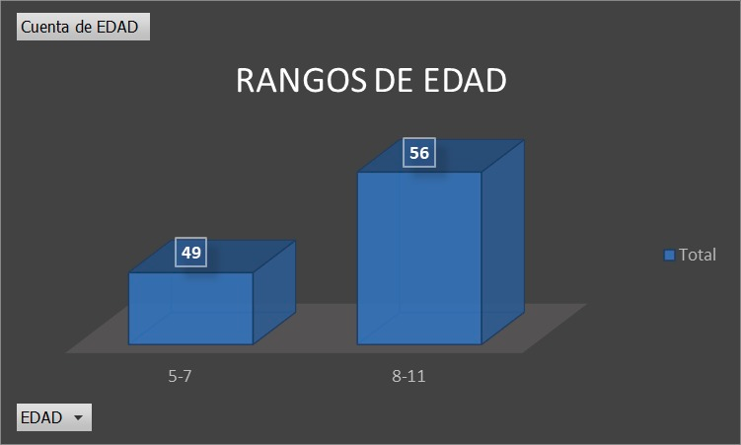
Figure 1. Age ranges.

Based on the graph, pes cavus is more common in older age groups.

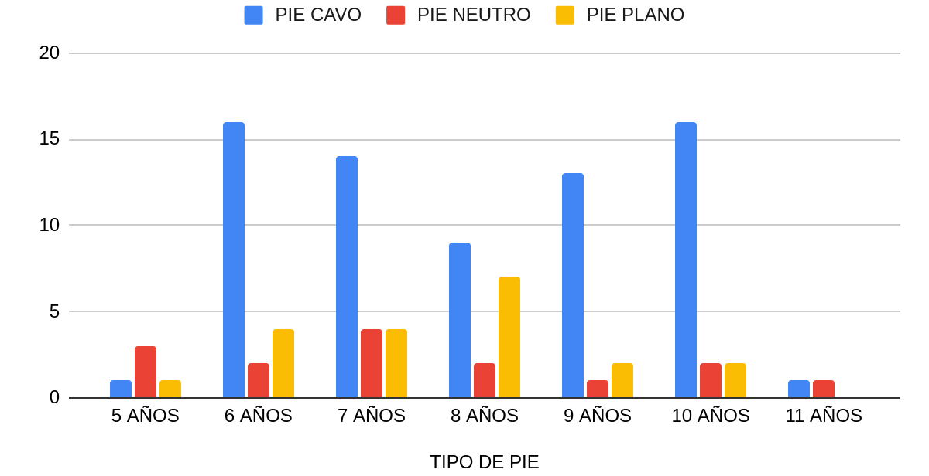
Figure 2. Foot Type by Age

In terms of gender, it is evident that 80 of the participants—equivalent to 76.19%—were male, while 25 participants—representing 23.81%—were female, indicating a notable difference in this regard (Figure 2).

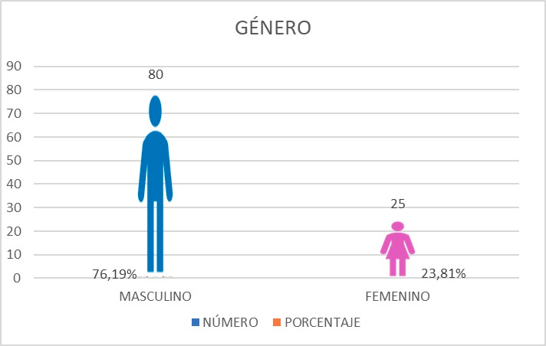
Figure 3. Percentage of participants by gender.

With regard to the participants’ gender, the results show that high arches are more common among women: 17 women had high arches, accounting for 68%; 4 women had normal arches; and 4 others had flat feet, accounting for 16% respectively. (Figure 3)

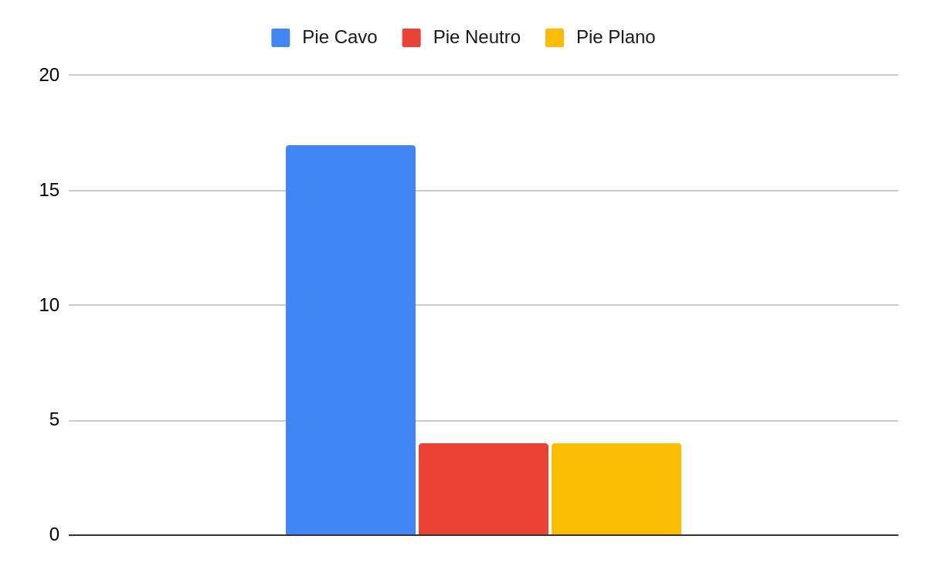
Figure 4. Foot Type in Relation to Females

Regarding foot shape in males, 77 individuals were found to have high arches, representing 65%; 11 individuals had normal arches, representing 13.75%; and 17 individuals had flat feet, representing 21.25%. (Figure 4).

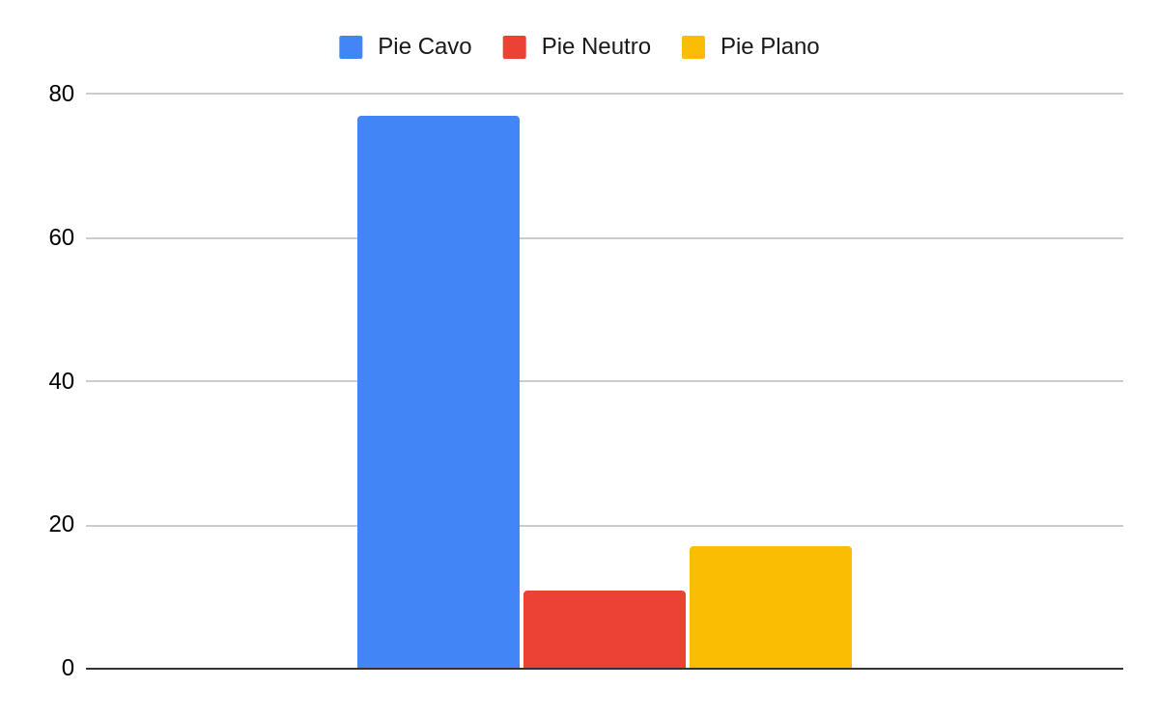
Figure 5. Foot Shape in Relation to Males

With regard to foot type, 70 participants had high arches, accounting for 66.67%; 20 children, or 19.04%, had flat feet; and 15, or 14.28%, had normal or neutral feet. In this group, the majority of participants show very pronounced signs of high arches, while a smaller group exhibits flat feet (Figure 5).

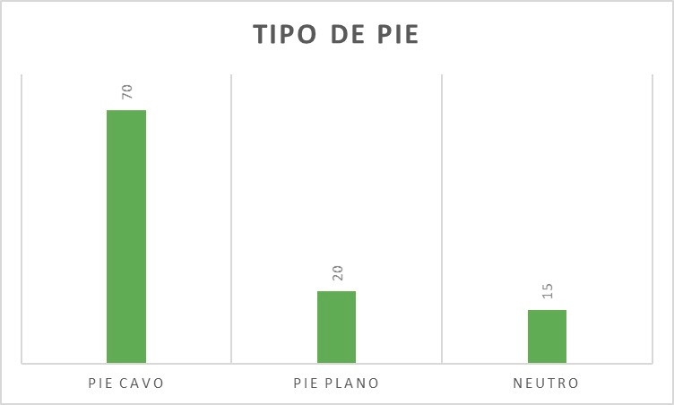
Figure 6. Number of participants by foot type.

Discussion and Conclusions
Studies on foot type in certain regions of Ecuador are scarce and limited; therefore, this review aims to identify the prevalence of foot type by age and sex. The results show a marked prevalence of high arches over flat feet in both men and women; this is supported by the studies mentioned earlier in this article, which showed that high arches are more common in areas geographically similar to Zámbiza.

The neutral foot type shows lower percentages than the other foot types, which indicates that high arches are more common in this age group in this region and may be more closely related to factors such as weight, physical activity, and the patient's age.
Given that similar results were observed in both females and males, we can conclude that there is no direct relationship between sex and foot type, since, in this study group, pes cavus was present in more than 60% of both the female and male groups.
Among children aged 6 to 10, there is a marked tendency for high arches to be more common than flat feet and neutral feet; among children aged 5 to 6, flat feet predominate, since in early childhood the human foot goes through stages of morphofunctional maturation. As mentioned earlier, the bones, muscles, and ligaments of the foot gradually strengthen to form the medial longitudinal arch.
Identifying these structural variations in the feet is important, as they provide information about the potential long-term consequences this population may face if corrective measures are not taken. Based on the studies reported in this review, the consequences that may arise are as follows: pain that may be diffuse in the feet, ankles, or legs, or even specific pain in the sole of the foot that worsens with movement; fatigue in the feet after standing, walking, or engaging in sports for an extended period; changes in gait that are evident through asymmetric wear on footwear and that, in turn, indicate uneven weight distribution.
Podiatric care and foot print analysis in children are essential for the early detection of abnormalities in arch development and foot biomechanics, which can affect posture, gait, and physical performance throughout childhood. A timely evaluation can help identify conditions such as flat feet or high arches, which, if left untreated, could lead to discomfort, muscle compensations, and future complications. Based on the above, pediatric podiatric care contributes to the early detection of conditions and provides guidance to parents or caregivers on the proper use of footwear, healthy habits, and preventive measures, thereby ensuring optimal motor development and reducing the risk of functional problems later in life.
A study analyzing the foot prints of children aged 5 to 11 in the city of Quito revealed a high prevalence of pes cavus in most of the age groups evaluated, making it a morphological abnormality that requires attention in both pediatric and podiatric settings. This finding highlights the importance of understanding the development of the arch of the foot in the local pediatric population, since the biomechanical characteristics of the foot during childhood can have a significant impact on posture, gait, and functionality later in life.
Similarly, the comparative analysis by sex revealed insignificant differences between boys and girls, with very similar percentages observed for the presence of pes cavus. This suggests that sex is not a determining predisposing factor in this sample, and that the identified trend may be more closely related to characteristics specific to the study population, as well as to possible environmental factors or common postural habits.
The findings provide relevant data for the implementation of preventive and control measures in the early stages. In this context, it is recommended to promote regular podiatric evaluations in schools, as well as to strengthen foot health education programs aimed at teachers, parents, and caregivers. Furthermore, it is essential to take this information into account to guide future research that explores associated variables, such as footwear type, physical activity level, family history, and the presence of concomitant musculoskeletal disorders.
Overall, this study expands our understanding of the behavior of the plantar arch in the pediatric population of Quito and highlights the need to implement measures to monitor and promote foot health from an early age. This will promote proper foot development and reduce the risk of future long-term biomechanical abnormalities.

Acknowledgments
The authors would like to thank MSc. David Córdova of the Instituto Superior Tecnológico Universitario Libertad for his guidance in the development of this project.

Conflict of Interest
The authors declare that they have no conflicts of interest, personal or financial, that could have inappropriately influenced the conduct, design, presentation, or interpretation of the results of this research.

References

1. Gómez Ríos Y, Londoño Y, Vallejo Osorio AN, Fuentes García JP, Poblete Valderrama F, Matus Castillo C, et al. Huella plantar y posturometría en estudiantes de Educación Física en edad escolar. Retos Nuevas Tend En Educ Física Deporte Recreación. 2023;(49):408-13.
2. Štefan L, Kasović M, Zvonar M. Association between the levels of physical activity and plantar pressure in 6-14-year-old children. PeerJ. 2020;8:e8551. doi:10.7717/peerj.8551 PubMed PMID: 32095366; PubMed Central PMCID: PMC7025699.
3. Motoche Santos VM, Nuñez Sánchez BL, Guaña Tarco LV, Yartú Couceiro R, Oleas López AE. Alteraciones de la huella plantar en preescolares del Centro Infantil del Buen Vivir “Francisco Chiriboga”. Eugenio Espejo. 2019;13(1 (Jan–Jun)):45–52.
4. Mosquera Flores MB, Maldonado Castillo SO. Tipo de huella plantar en los escolares de 10 a 15 años de edad de la Escuela de Educación Básica Ignacio Escandón-Cuenca, período septiembre 2022-febrero 2023 [Internet]. April 4, 2023 [cited March 26, 2026]. Retrieved from: http://dspace.ucuenca.edu.ec/handle/123456789/41593
5. Moran KSP, Ramirez ASA, Caicedo SEV, Grijalva IOG, Lajones AEB. Análisis de Alteraciones Posturales y Huella Plantar en Escolares. Cienc Lat Rev Científica Multidiscip. September 22, 2025; 9(4):9426-39. doi:10.37811/cl_rcm.v9i4.19503
6. Baranowska A, Sierakowska M, Owczarczuk A, Olejnik BJ, Lankau A, Baranowski P. An Analysis of the Risk Factors for Postural Defects among Early School-Aged Children. J Clin Med. 11 de julio de 2023;12(14):4621. doi:10.3390/jcm12144621 PubMed PMID: 37510735; PubMed Central PMCID: PMC10380383.
7. Wang Y, Jiang H, Yu L, Gao Z, Liu W, Mei Q, et al. Understanding the Role of Children’s Footwear on Children’s Feet and Gait Development: A Systematic Scoping Review. Healthcare. May 13, 2023;11(10):1418. doi:10.3390/healthcare11101418 PubMed PMID: 37239704; PubMed Central PMCID: PMC10218108.
8. GarcÃ­a-DomÃ­nguez J de D, DÃ­az-Lima M. Flexible flatfoot in the childhood: negative influence of inappropriate footwear. Rev Médica Electrónica. 1 de marzo de 2023;45(2):e4671-e4671.
9. Martín-Casado L, Palomo-Fernández I, Aldana-Caballero A, Baltasar-Fernandez I, Marcos-Tejedor F. High Rate of Change of the Foot in Ecuadorian Children: The Need for Proper Shoe Design. Children. 20 de junio de 2024;11(6):749. doi:10.3390/children11060749 PubMed PMID: 38929328; PubMed Central PMCID: PMC11201716.
10. Ramos-Frutos JA, Miguel-Andrés I, León-Rodríguez M, Ortiz-Lango LA, Orozco-Villaseñor SL, Vidal-Lesso A, et al. Type of Feet in a Mexican Population: Analysis of the Footprint Morphology and Literature Review. Rev Mex Ing Bioméd. agosto de 2023;44(2). doi:10.17488/rmib.44.2.1
11. Obesidades en la infancia | Pediatría integral [Internet]. July 6, 2020 [cited March 26, 2026]. Retrieved from: https://www.pediatriaintegral.es/publicacion-2020-06/obesidades-en-la-infancia/
12. Abich Y, Mihiret T, Akalu TY, Gashaw M, Janakiraman B. Flatfoot and associated factors among Ethiopian school children aged 11 to 15 years: A school-based study. PLOS ONE. August 25, 2020; 15(8):e0238001. doi:10.1371/journal.pone.0238001
13. Seaman TJ, Ball TA. Pes Cavus. In: StatPearls [Internet]. Treasure Island (FL): StatPearls Publishing; 2026 [cited March 26, 2026]. Retrieved from: http://www.ncbi.nlm.nih.gov/books/NBK556016/ PubMed PMID: 32310476.
14. Burbano Peñafiel PA, Viteri Zapata SG. Análisis del apoyo plantar estático en niños escolares de 7-8 años de edad y su correlación con la postura, índice cintura-cadera y actividad física [bachelor Thesis] [Internet]. Quito: Universidad de las Américas, 2018; 2018 [cited March 26, 2026]. Retrieved from: http://dspace.udla.edu.ec/handle/33000/9896
15. Martín-Casado L, Palomo-Fernández I, Aldana-Caballero A, Baltasar-Fernandez I, Marcos-Tejedor F. High Rate of Change of the Foot in Ecuadorian Children: The Need for Proper Shoe Design. Children. June 2024;11(6):749. doi:10.3390/children11060749

