 | MLS – HEALTH & NUTRITION RESEARCH (MLSHNR)  http://mlsjournals.com/Health&nutritionrsearch-Journal  ISSN: 2603-5820 | 
(2026) MLS-Health & Nutrition Research, 5(1),64-92 doi.org/10.60134/mlshn.v5n1.4594

Impacts of a holistic virtual program on nutritional status, eating habits, physical activity level, and health in adults with overweight or obesity

Impactos de un programa virtual holístico sobre estado nutricional, hábitos alimentares, nivel de actividad física y salud en adultos con sobrepeso u obesidad

Alberto Nilson
Universidad Europea del Atlántico (alberto.a.nilson@gmail.com) (https://orcid.org/0009-0000-5786-8060)

Manuscript information:

Recibido/Received:02/12/25
Revisado/Reviewed: 05/12/25
Aceptado/Accepted: 02/06/26
 | Abstract
Keywords:  Virtual nutritional reprogramming, virtual weight loss, online intervention for healthy living, eating and physical habits change. | A virtual holistic weight-loss program (body, mind and nutrition) was evaluated, with the aim of transforming eating habits, physical activity and improving health in 28 participants with BMI > 27.5. The intervention guided participants to moderate energy-dense foods, prefer foods with high nutritional density and moderate the glycemic load of meals. To facilitate the changes, periodic virtual reinforcements were used: videos, weekly meetings, a forum and individual contacts. In addition, behavioural and psychological support was provided: cognitive-behavioural therapy, mindfulness, stress control, reduction of the restriction-frustration-guilt cycle and continuous improvement spiral. A statistically significant increase was observed in the consumption of sweet fruits, green leafy vegetables and non-sweet fruits, alongside a decrease in cereals, starchy tubers, legumes, dairy products, processed animal-origin foods and refined oils/fats. The average weekly physical-activity time rose from 185 min to 241 min (statistically significant), surpassing the 150 min recommended by the World Health Organization. In 12 weeks, a mean reduction, statistically significant, of 5.6 kg (~6.8 % of initial weight). Current programs take twice the time to get similar results. Additionally, there was a reduction of 3.3 kg total fat and 1.5 kg visceral fat. Improvements in health and comorbidities were reported, with no negative effects. The dropout rate was 14 %, significantly lower than rates observed in similar programs. In summary, the virtual program fully achieved its objectives, emerging as a promising alternative for healthy-weight-loss.
 | RESUMEN
Palabras clave:  Reprogramación alimentaria virtual, adelgazamiento virtual, intervención online para vida saludable, cambio de hábitos alimentarios y actividad física. | Se evaluó un programa virtual de adelgazamiento holístico (cuerpo, mente y alimentación), con el objetivo de transformar hábitos alimentarios, actividad física y mejorar la salud en 28 voluntarios con IMC > 27,5. La intervención orientó a moderar alimentos con alta densidad calórica, preferir alimentos con alta densidad nutricional y moderar la carga glucémica de las comidas. Para facilitar los cambios se emplearon refuerzos virtuales periódicos: vídeos, encuentros semanales, foro y contactos individuales. Además, contó con apoyo conductual y psicológico: terapia cognitivo-conductual, consciencia plena (mindfulness), control del estrés, reducción del ciclo restricción-frustración-culpa y espiral de mejora continua. Se observó un aumento estadísticamente significativo en el consumo de frutas dulces, hojas verdes y frutos no dulces, junto con una disminución de cereales, tubérculos amiláceos, leguminosas, derivados lácteos, alimentos de origen animal procesados y aceites/grasas refinadas. El tiempo medio semanal de actividad física pasó de 185 min a 241 min (estadísticamente significativo), superando los 150 min recomendados por la Organización Mundial de la Salud (OMS). En 12 semanas, se constató una disminución media, estadísticamente significativa, de 5,6 kg (~6,8 % del peso inicial). Programas existentes demoran el doble del tiempo o más para conseguir el mismo resultado. Además, se tuvo reducción de 3,3 kg de grasa total y 1,5 kg de grasa visceral. Se informaron mejoras en la salud y comorbilidades, sin efectos negativos. La tasa de abandono fue del 14 %, significativamente inferior a programas similares. En síntesis, el programa virtual alcanzó íntegramente sus objetivos, revelándose como una alternativa prometedora para alcanzar un adelgazamiento saludable.

Introduction

Overweight and obesity, defined by a Body Mass Index (BMI) > 25 kg/m² and > 30 kg/m², respectively, along with their associated comorbidities, have reached pandemic proportions, with no clear signs of reversal [1].
In 2022, approximately 43% of the world's population was overweight, and 16% was obese. The World Health Organization (WHO) estimates that by 2030, nearly 1 trillion adults and 340 million children could be living with obesity [2]. In 2023, 61.4% of the Brazilian adult population was overweight, and 24.3% was obese [3].
In the United States, obese individuals incur medical expenses that are 41% higher [4]. In 2020, the overall economic impact of obesity in the Americas accounted for more than 3% of the Gross Domestic Product [5]. In Brazil, it was 1.98% in 2019, with projections of 4.66% for 2030 [5].
Comorbidities include cardiovascular disease, type 2 diabetes, certain types of cancer, hypertension, and chronic kidney disease, among others, which significantly contribute to a reduction in quality of life and life expectancy [6].
The excellent metabolic and cardiovascular health of hunter-gatherers, a result of their lifestyle, leads them to be considered ideal models for public health promotion [7].
They were nomads and maintained a varied diet consisting of fruits (both sweet and non-sweet), non-starchy tubers, cruciferous vegetables, lean animal products, mushrooms, nuts, and honey. They engaged in adequate levels of physical activity, which helped maintain their energy and metabolic balance [8].
Metabolic flexibility allows the body to switch between fats and carbohydrates as energy sources, enabling it to adapt well to seasonal and regional variations in food supply, with weight fluctuations within parameters considered healthy [8].
With an average life expectancy of less than 30 years, the leading causes of death were: infections, high infant mortality, accidents, and violence [9]. Even among people over 50, noncommunicable diseases were very rare [10]. What changed?
The causes of obesity are complex and can be grouped into the following categories: genetics, physical activity, mental health, diet, and environmental pollutants.
It is estimated that genetics could account for between 40% and 70% of the predisposition to developing obesity [2]. However, the transition from hunter-gatherer societies to modern lifestyles was too brief to allow for major genetic changes that would contribute to obesity. What happened was that the environmental changes were so drastic that genetics did not have time to adapt to the new conditions [11].
We constantly hear that one of the causes of obesity is a sedentary lifestyle. However, while hunter-gatherers engage in higher levels of physical activity (they walk a lot, move around, and forage), recent studies show that their daily energy expenditure was not significantly higher than that of the average modern population [10].
This explains why the WHO's recommendations are moderate: 150 to 300 minutes per week of moderate-intensity aerobic activity, or 75 to 150 minutes of vigorous-intensity activity, or an equivalent combination. In addition, older adults should engage in muscle-strengthening activities that involve all major muscle groups at least two days a week [12].
Even so, it is estimated that approximately 81% of adolescents (ages 11–17) and 27.5% of adults worldwide do not meet the recommended levels of physical activity [13].

The relationship between mental health and obesity is complex and bidirectional, with interdependent effects [14], including: chronic stress, anxiety, depression, emotional eating, sleep disorders, and issues related to self-image and self-esteem [15].

The transition to modern lifestyles transformed the neuropsychological processes involved in appetite, satiety, and energy regulation. The brain's reward circuit, which evolved to respond to food scarcity, is now overstimulated by highly palatable processed foods. In addition, sleep disturbances and circadian rhythm disruption—which are common in urban environments—alter key hormones such as leptin (satiety) and ghrelin (hunger) [16]. These endocrine changes are accompanied by mechanical eating behavior (eating without feeling hungry) and reduced physical activity. Taken together, the interplay of heightened reward sensitivity, reduced inhibitory control, hormonal disruption, and automated habits creates a psychological and neural environment conducive to excess calorie intake, overweight, and noncommunicable diseases.

In Brazil, approximately 60% of patients with obesity have some form of psychiatric disorder—particularly stress, depression, and binge-eating disorder [17]. Mental health is also closely linked to nutrition. Even marginal nutritional deficiencies negatively affect brain and nervous system function [18]. Obesity, for its part, promotes a state of hidden chronic inflammation, a factor recognized in the pathophysiology of depression and other neurological disorders [19].
A significant portion of the “traditional” diet of hunter-gatherers was replaced by the “new” foods of the modern diet. The mastery of fire made it possible to consume starchy foods (grains, starchy tubers, and legumes). The agricultural revolution led to an abundance of these foods, [8,20,21]. Fatty meats from domestic animals replaced lean meats from game [22]. We use milk and milk products. The Industrial Revolution led to the widespread use of refined foods (white wheat flour and white rice). It also made it possible to produce highly refined foods, such as sugars, oils and fats, starches, and distilled alcohols [23]. All of these new foods replaced a significant portion of the foods from Origins [24].
At the beginning of the last century, the food industry revolution led to the development of a wide range of food additives (colors, flavorings, acidulants, emulsifiers, preservatives, antioxidants, non-caloric sweeteners, thickeners, anti-caking agents, among others) [25], many of which are highly controversial in terms of their safety [26].
These additives, along with advances in food processing and the communications revolution, paved the way for the industrialization of cookies [27], bread [28,29], pasta [30], potato chips [31], refined sugar [32]. In addition, carbonated beverages appeared for the first time: 1904 [33], refined vegetable oils: 1920 [34] fast food: 1921 [35], ready-to-use industrial cake mix: 1940 [36], corn flakes: 1930 [37], hydrogenated oils (trans fats): [34], In addition, the consumption of french fries at fast-food chains became popular [31], as did pizza with the advent of quick delivery services: 1980 [38], industrialization of rice cultivation and refining: 1940 [39] and the spread of the rice-and-beans combination in Brazil: 1960 [39]. All of this comes together in a Perfect Food Storm.
This led to significant changes in nutrition, the most important of which were: an increase in the consumption of foods with high caloric density and low nutritional density, and an increase in the glycemic load (GL) of meals.
a) Caloric Density
One of the keys to losing weight is to increase calorie expenditure and reduce calorie intake to maintain a deficit.
Based on U.S. food composition tables. [40] The ranges of caloric density (calories per 100 g) were determined for different food groups. Figure 1 illustrates a comparison between “Traditional” and “New” foods, with the latter having a significantly higher calorie density, which is associated with overweight and obesity [41].
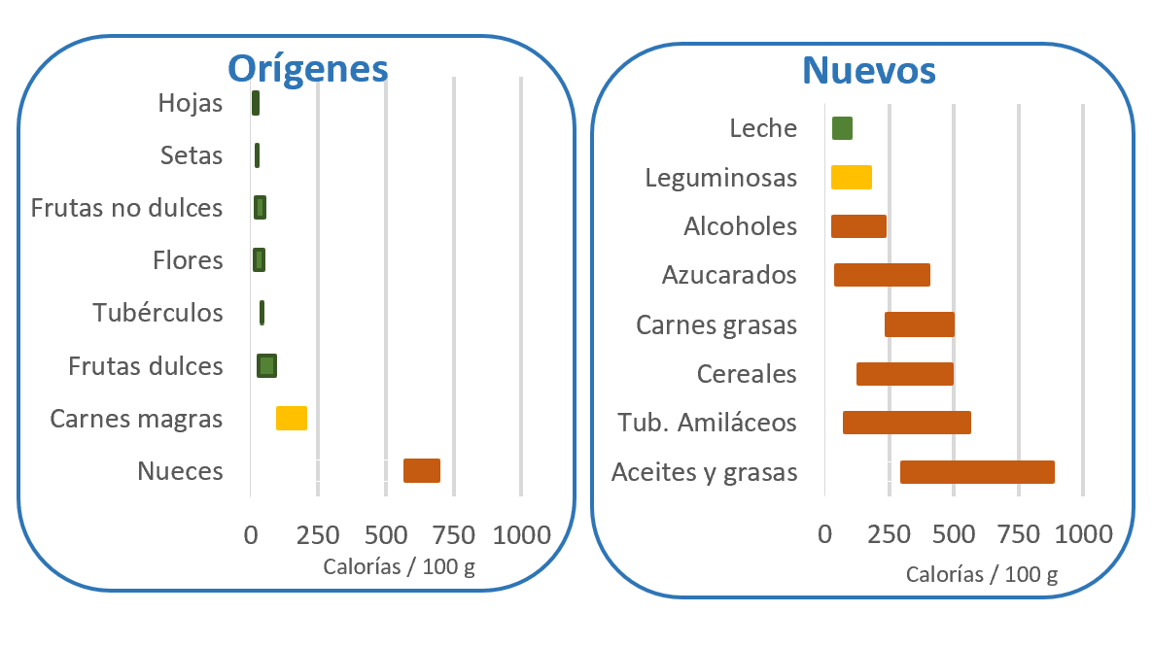
Figure 1: Caloric density
(Green: Cancel. Yellow: Media. Red: Sign Up)

b) Nutritional Density
There has recently been growing concern about ensuring an adequate intake of essential nutrients to combat the “double burden of malnutrition” (obesity caused by consuming too many calories, combined with nutritional deficiencies caused by eating nutrient-poor foods). These nutritional deficiencies, even when mild, are enough to disrupt our metabolic, physical, and mental performance, hindering efforts to lose weight and maintain a healthy weight [42]. Unfortunately, nutritional deficiencies are common in many restrictive diets [43]. One consequence of these nutritional deficiencies is low-grade (hidden) chronic inflammation, which, although it does not cause any direct symptoms, is responsible for most comorbidities in people who are overweight or obese [44].
Guiding the population in a simple and effective way toward an adequate intake of nutritious foods is a challenge due to factors such as: low nutritional/food literacy [45], information overload and misinformation [45], resistance to changing habits, socioeconomic and food access barriers, and limitations among health professionals [46].
Various initiatives have been implemented, including dietary re-education [47], dietary guidelines [48], nutrition labeling [49], nutrition claims [50] and front-of-package labeling [51], with results falling short of expectations.
A recent proposal is the concept of Nutritional Density [52]. For this paper, the following definition was chosen: “times the daily requirement for a nutrient, based on the amount of food that meets the daily requirement in terms of calories.”
To operationalize this concept, the Recommended Daily Intake (RDI) values for each nutrient, as defined by the Food and Nutrition Board of the U.S. National Academies, were used. [53], in combination with data from U.S. food composition tables. [40], allowing for the calculation of the percentage of a nutrient’s daily requirement present in 2,000 calories (the requirement for an average adult male). Next, the average was calculated for 12 vitamins, 8 minerals, fiber, and protein.
It was observed that foods within the same group tend to be rich or poor in the same nutrients [54]. This allowed us to estimate the representative average nutritional density for a food group, taking into account the most characteristic foods.
In Figure 2, we can see that “Original” foods have high nutritional density, while most “New” foods have low nutritional density; some of them are even “empty calories” (they provide calories but little or no other essential nutrients).
Although this assessment does not include polyphenols—since no RDI has been established for them—we know that fruits (both sweet and non-sweet), cruciferous vegetables, non-starchy tubers, mushrooms, and nuts are rich in these nutrients. The polyphenol content of modern foods, especially refined ones, is already significantly lower [55,56], which underscores the high nutritional value of Orígenes foods.

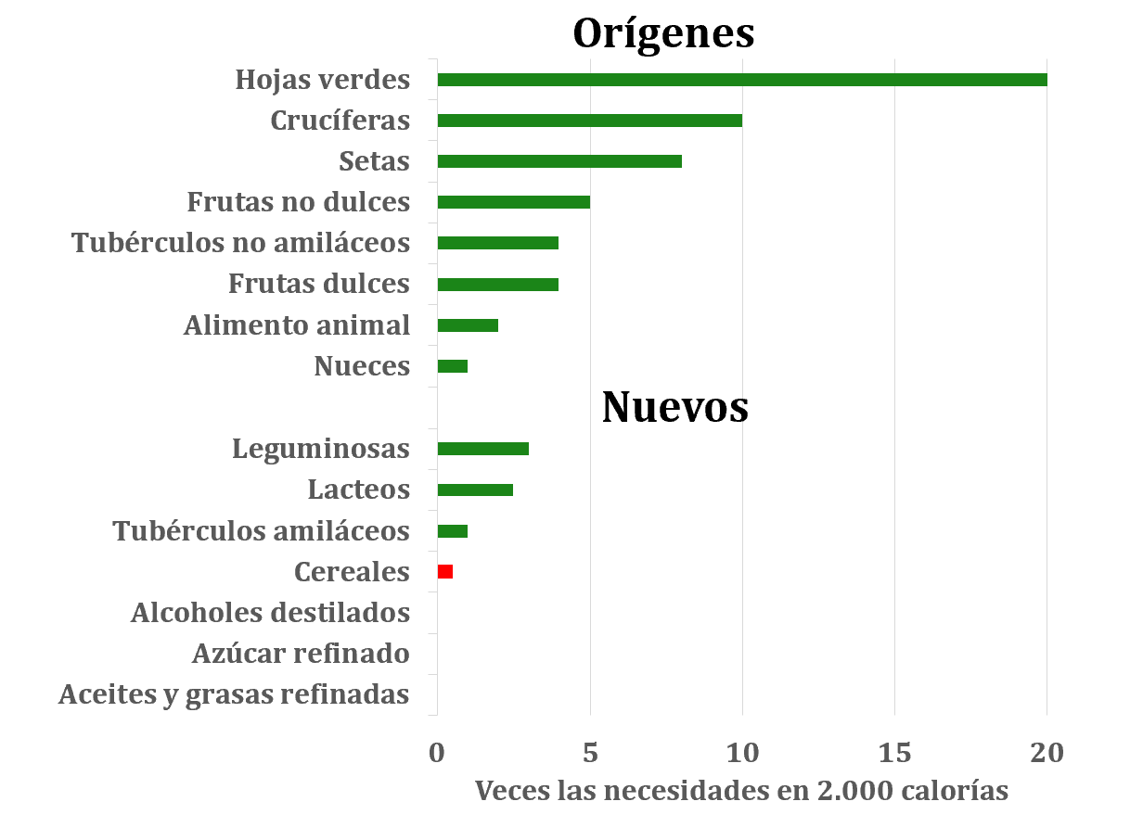
Figure 2: Average Nutritional Density by Food Group

Furthermore, by comparing Figures 1 and 2, we can see that most foods with low caloric density also have high nutritional density, establishing a synergy between the two concepts and making it easier to choose more appropriate foods [57].
It is striking to note that 45.2% of the calories in the modern Western diet come from empty calories (refined oils, fats, and sugars) and 21.9% from foods with low nutritional density (grains and starchy tubers). Fruits and vegetables account for just 4.4% of the calories. Foods of animal origin account for 25%, while legumes, nuts, and oilseeds—which have an average nutritional density—account for just 4.4% [24]. This explains the high prevalence of nutritional deficiencies.
c) Glycemic Load (GL)
It is recommended to prioritize foods with a low glycemic index (GI) [58]. However, it is the CG (GI multiplied by the amount of carbohydrates in a serving) that determines a meal’s glycemic response, which is classified as low < 10 g, moderate 11 to 19 g, and high > 20 g [59].
Frequent consumption of meals with a high glycemic load results in constant, sharp spikes in blood glucose and insulin levels, which are associated with obesity and its comorbidities [60].
Excess glucose is stored as glycogen in the muscles and liver. As glycogen stores become saturated, excess glucose is converted into fatty acids and stored in adipose tissue. Calories from fat and excess protein follow the same path. As a result, the body's metabolism is geared toward using glucose as its primary source of energy. To burn fat (both stored fat and fat from food), it is necessary to moderate the glycemic load of meals to reduce glycogen stores, which allows the metabolism to shift. [61].
Although it is difficult to estimate the ketogenic potential (CG) of the hunter-gatherers’ diet, all evidence suggests that it was extremely low, fluctuating between ketogenic periods (very low) and low periods (around 10 g) [62]. A recent assessment found that the average daily carbohydrate intake in the U.S. is 133 g, which is equivalent to 44 g per meal (assuming the population eats 3 meals per day) [63], well above the diet described in *Origins*.
d) Other Changes
Heat treatment destroys vitamins and promotes adverse reactions, such as the formation of acrylamide (resulting from the interaction between starches and proteins) and nitrosamines (formed by the reaction of nitrite with proteins), both of which are recognized as carcinogens [64].
Convenience, combined with today’s fast-paced lifestyle, has altered traditional eating patterns: greater reliance on fast food, frequent eating away from home, and less time spent preparing meals, all of which negatively impact the nutritional quality of the diet [64].
Genetic selection has made it possible to select plants and animals with favorable genetic traits, such as resistance to environmental variations, disease tolerance, higher productivity, and better organoleptic qualities [65]. However, varieties with lower nutritional value and higher levels of toxins and antinutrients were inadvertently selected [65].
In addition, environmental pollution worsened as a result of the introduction of chemical compounds that persist in the environment [66]. Among these, endocrine disruptors (such as bisphenol A, phthalates, pesticides, and flame retardants) stand out, as they are implicated in hormonal and metabolic dysfunction [67], antibiotics, and growth-promoting hormones used in animal feed, whose residues induce bacterial resistance and potential endocrine imbalances in consumers [64]. The role of pesticide/agrochemical use in the onset or worsening of chronic noncommunicable diseases is increasingly well documented [68]. At the same time, nanoparticles (<100 nm) originating from industrial processes were detected; their toxic effects include oxidative stress, inflammation, and possible cellular damage [69,70]. The environment was also contaminated with heavy metals, such as lead and cadmium [71], as well as complex chemical mixtures (pesticides, herbicides, PCBs, PFAS) [72]. Finally, combustion gases generate a variety of air pollutants—gases and particulate matter—that contribute significantly to the development or worsening of noncommunicable diseases [73].
Various medications can contribute to the development of obesity by increasing appetite, causing fatigue, or interfering with nutrient absorption. Notable among these drugs are those used to treat diabetes, epilepsy, and high blood pressure, as well as antipsychotics and antidepressants [74]. Treating a comorbidity can contribute to the onset or worsening of obesity, which will make it more difficult to treat the comorbidity being addressed and may lead to the development of other comorbidities.
The dramatic decline in height following the onset of the agricultural revolution was already a warning sign. Reliance on a limited variety of foods and living in settlements led to a decrease in life expectancy, an increase in infectious diseases, and a rise in nutritional deficiencies [75].
The refining of foods during the Industrial Revolution led to an increase in nutritional deficiencies: scurvy (vitamin C), pellagra (niacin), beriberi (vitamin B₁), iron-deficiency anemia (iron), goiter (iodine), xerophthalmia (vitamin A), spina bifida (folic acid), among others [23].
Overcrowding in permanent settlements, combined with reduced immunity, contributed to the spread of infectious diseases [75]. At the same time, changes in diet led to alterations in the composition of the gut microbiota [75].
It is estimated that more than 50% of deaths from noncommunicable diseases are related to low-grade (hidden) chronic inflammation [44]. There is a vicious cycle between hidden inflammation and obesity. Silent inflammation disrupts metabolism and negatively affects the regulation of hunger and satiety, leading to an increase in adipose tissue, which, in turn, contributes to the production of elevated levels of inflammatory cytokines, thereby perpetuating the cycle of silent inflammation [76]. This inflammation is caused by: spikes in blood glucose and insulin levels [77] high consumption of trans fats [78]; a high omega-6 to omega-3 ratio [79]; additives in processed meats [80]; excessive alcohol consumption [81]; allergies [82]; gut microbiota dysbiosis [83]; lactose intolerance [84]; gluten intolerance [85]; artificial additives [86]; environmental contaminants, pesticides, heavy metals [87]; nutritional deficiencies, particularly of antioxidant and anti-inflammatory nutrients [88]; stress [89]; sedentary lifestyle [90]; low intake of soluble fiber [91]; smoking [92]; endocrine disruptors [93] and sleep disturbances [94] Various studies indicate that, to combat hidden inflammation, it is necessary to reduce exposure to the aforementioned inflammatory agents and adopt a diet rich in anti-inflammatory compounds [95].
Starting in the 20th century, there were major advances in vaccines, antibiotics, sanitation, medical care, disease diagnosis and treatment, better education, food fortification, increased purchasing power, and a reduction in smoking, all of which contributed to increased life expectancy [96]. Conversely, the rise in noncommunicable diseases due to changes in diet is causing life expectancy to begin to decline [97].
The modern Western diet causes an imbalance in the gut microbiota (dysbiosis), which is associated with metabolic problems, inflammatory diseases, mental health issues (such as anxiety and depression), and gastrointestinal disorders [98].
The intervention program focuses on managing the three most important hormonal systems involved in regulating satiety: 1) Maintain stable blood glucose and insulin levels by eating meals with a moderate glycemic load [99]. 2) Keep ghrelin levels low by choosing foods that remain in the stomach longer [100–102], where, for proteins, it is longer than for saturated fats and longer than for fiber [103]. 20 to 30 g of protein produce a feeling of fullness that lasts 3 to 6 hours. Larger amounts do not significantly increase this effect [104]. 3) Maintain an adequate intake of protein, soluble fiber, polyphenols, and omega-3 fatty acids, all of which play a crucial role in regulating appetite through the hormone GLP-1 (glucagon-like peptide) [105].
Strategies for combating obesity include: dietary education, diets, regular physical activity, medication, meal replacements, and bariatric surgery [106].
Diets include calorie, fat, or carbohydrate restriction; alternative eating patterns (Mediterranean, Paleolithic, vegetarian/vegan, ketogenic, and carnivore); intermittent fasting; and the use of meal replacements [107,108].
Governments have contributed by developing dietary guidelines [109], nutrition labeling [110], front-of-package labeling [111], nutritional claims [112] and taxes on foods considered unhealthy.
Despite the individual advantages of each strategy, the “rebound effect” remains a common problem. In addition, the effectiveness of weight loss tends to decrease with successive attempts [113].
The importance of healthcare professionals is clear [114]. However, many doctors do not feel adequately prepared [115]. In addition, clinical practice often focuses on pharmacological treatments, while lifestyle changes receive less attention [115]. The importance of psychology has recently been highlighted [116]. A holistic approach involving doctors, nutritionists, and psychologists yields better results [117].
The media has a complex relationship with obesity and noncommunicable diseases. The industry frequently advertises unhealthy products [118], Promotion of healthy foods is rare and limited to isolated initiatives by small producers or regional associations [119]. In addition, digital media often portray unrealistic body standards and lifestyles, promoting harmful eating and physical activity habits [120]. Misinformation and vague advice increase consumer confusion, leading them to make poor choices [118]. Incorrect information tends to persist in the media, prolonging the confusion [118].
Information Technology (IT) solutions can be used to develop healthy habits. In Brazil, most people own a cell phone [121] and spend an average of more than 4 hours on social media, with WhatsApp, Facebook, and Instagram being the most widely used [122]. Advances in 5G technology enable fast data transmission, leading to a better experience [123]. The Brazilian healthcare market is rapidly adopting IT [124,125]. There are already apps for tracking habits, physical activity, nutrition, heart rate, and sleep patterns. There are communities for sharing experiences and providing mutual support [126]. Virtual coaching services provide personalized professional guidance through digital platforms. Artificial intelligence is rapidly making inroads into the Brazilian healthcare sector [127].
A recent publication evaluated 8 studies that used web-based platforms and showed good results [128]. Another meta-analysis found that interventions using IT produce better results [129].
Changing habits requires considerable effort and time [130]. Barriers include: lack of motivation, an unfavorable environment, lack of knowledge, fear of failure, old habits that are difficult to break, lack of social support, unrealistic expectations, lack of time, and resistance to change [131,132]. Deep-rooted misconceptions cause confusion and are difficult to change [133].
Nutrition is a relatively new and highly complex science that requires large-scale, long-term research and significant resources, which means that areas of uncertainty still exist (for example: margarine or butter, whether or not to eat eggs, fruit for people with diabetes, etc.) [134]. Commercial and political interests, as well as inappropriate professional practices, contribute to this confusion (for example, the myth—dating back more than 70 years—about the harmful effects of saturated fats) [135].
To make matters more complicated, we have to deal with the forgetting curve (in a week, we’ll remember about 20% of what we saw today) [136]. Frequent reinforcement at short intervals is more effective than spaced reinforcement in promoting sustainable changes [137].
The cost of in-person professional coaching makes it difficult for many people to attend frequent sessions aimed at changing habits [138].
Table 1 provides a summary of the holistic restructuring plan under review:

Table 1: Elements of the intervention plan
- Limit foods that are high in calories,
- Choose foods with high nutritional density
- Keep the glycemic load to about 10 g per meal; ideally, one piece of fruit
- Eat meals before you feel hungry (about every three hours).
- Start every meal with a glass of water.
- Start lunch and dinner with a hearty salad, followed by a serving of animal-based food (approx. 125 g raw, equivalent to 100–110 g cooked) accompanied by a generous portion of hot vegetables. Finish with a source of carbohydrates, ideally a piece of fruit.
- Engage in moderate and enjoyable physical activity
- A continuous process of education, persuasion, and reinforcement based on evidence, through daily videos, weekly virtual meetings, a forum, and personal contact via WhatsApp
- Use of psychological tools: developing a big-picture perspective, the spiral of continuous improvement, cognitive-behavioral therapy, mindfulness, and coping with stress and the cycle of restrictions, frustrations, and guilt.

Method

To assess the effectiveness of the proposed program, an experimental, longitudinal, descriptive study with a mixed-methods approach (qualitative and quantitative) was designed and approved by the Brazilian Ethics Committee.
Participants were selected using non-probability sampling, by sending a WhatsApp message to the researcher’s circle of contacts. Eligible participants were those over 18 years of age, with a BMI > 27.5, who were comfortable using cell phones, who wished to lose weight, and who were able to attend the initial and final in-person meetings. Pregnant women, people with eating disorders (bulimia, anorexia nervosa, and binge eating disorder), and vegans were excluded.
A total of 50 participants completed the online medical history questionnaire, which asked about gender, age, height, weight, target weight, physical activity, diagnosed comorbidities (type 2 diabetes, hypertension, depression, high cholesterol, constipation, fatty liver, hypothyroidism, anemia, osteoporosis, sarcopenia), use of supplements, weight-loss medications, and regularly taken medications, food intolerances, stress levels, and general aspects of eating habits and attitudes.
Of the 28 people who signed the Informed Consent Form and began the program, four dropped out (a dropout rate of 14%). Two people were unable to participate in the final event (one had a leg in a cast and the other was on a business trip), but these are not considered withdrawals. Twenty-two people completed the program (20 women and 2 men), with an average age of 57.5 years.
Participants were added to a WhatsApp forum to share experiences and ask questions, and they registered on the support platform (www.praam.net), which provides daily videos ranging from 5 to 10 minutes in length. In addition, the platform provides a summary of the appropriate serving sizes for 10 g of CC (culinary units, weight, calories, and nutritional density) for the most common foods,
Participants were asked to complete online questionnaires on Eating Habits (developed and validated by the ELSA-Brazil project [139], which measures the frequency of food consumption) and Physical Activity (developed and validated by the ELSA-Brazil project [140], which assesses the type, frequency, duration, and intensity of activity).
Based on the responses, individual evaluations—including areas for improvement and personalized action plans—were sent (via private WhatsApp). In the most challenging cases, a personalized virtual meeting was held to exchange ideas. Participants with high levels of stress and depression were advised to seek additional professional support. To prevent demotivation, those with unrealistic goals were advised to adjust their goal to losing about 10 kg during the first three months of the program.
Participants were invited to an in-person session for fasting weight measurement (between 8:00 a.m. and 9:00 a.m.) using bioimpedance (an Omron scale, model HBF-226, which measures: weight (kg ± 100 g), total body fat (% of total weight ± 0.1%), visceral fat (% of total body fat ± 1%), and skeletal muscle mass (% of total weight ± 0.1%)). After weigh-in and breakfast, there was a brief introduction to the program.
In order to correct any preexisting nutritional deficiencies and dysbiosis that could compromise the program’s effectiveness, it was suggested that a vitamin-mineral supplement, probiotic, prebiotic, and omega-3 be included during the first month.
We have asked that you post your fasting weight on Fridays—using your own scale—either on the forum or via personal WhatsApp. In return, they received feedback through the same channel, with the goal of boosting their self-esteem and identifying opportunities for improvement, in line with the concept of the spiral of continuous improvement.
The content and sequences of the daily videos were designed to persuade and gradually encourage the changes listed in Table 1.
The virtual group meetings, held every Saturday and lasting about an hour (recorded so participants could watch them later if necessary), supported the process of changing habits by answering questions and sharing experiences.
If necessary, participants were able to contact the program mentor privately (via WhatsApp) to discuss confidential matters. Similarly, the mentor reached out to participants who were underperforming in order to assess their challenges and support them through the process of change.
At the end of 12 weeks, another in-person visit was held to measure the final body composition (weight, total body fat, visceral fat, and skeletal muscle mass), and participants were asked to complete the Dietary Habits and Physical Activity questionnaires again. In addition, participants were asked to complete the “How Was My Journey?” questionnaire, which assessed their perceptions of improvements in health (overall and regarding preexisting conditions) and their level of satisfaction with the videos (number viewed, clarity, and relevance of the content), virtual meetings (participation and usefulness), the WhatsApp forum (participation and usefulness), and their willingness to recommend the program.
After the 12-week intensive period ended, participants continued in the program for another 9 months, with the difference that there were no longer daily videos and the virtual meetings became monthly, aimed at reinforcing the changes in habits they had developed.

Results

Table 2 shows the p-values for Student’s t-test for paired samples and the effect size measured by Cohen’s d, confirming that there was a statistically significant increase in the frequency of consumption of “Traditional” foods and a statistically significant decrease in the frequency of consumption of “New” foods. Among the Orígenes foods, there was a statistically significant increase in the consumption of sweet fruits, leafy greens, and vegetable soup. The reduction in non-sweet fruit is at the statistical threshold. In the “New” food group, a statistically significant decrease was observed for: cereals, starchy tubers, legumes, dairy products, processed animal-based foods, and refined oils and fats. These changes are in line with the goal of reducing the intake of foods with high caloric density (Figure 1) and increasing the intake of foods with high nutritional density (Figure 2).

Table 2: Changes in Eating Habits
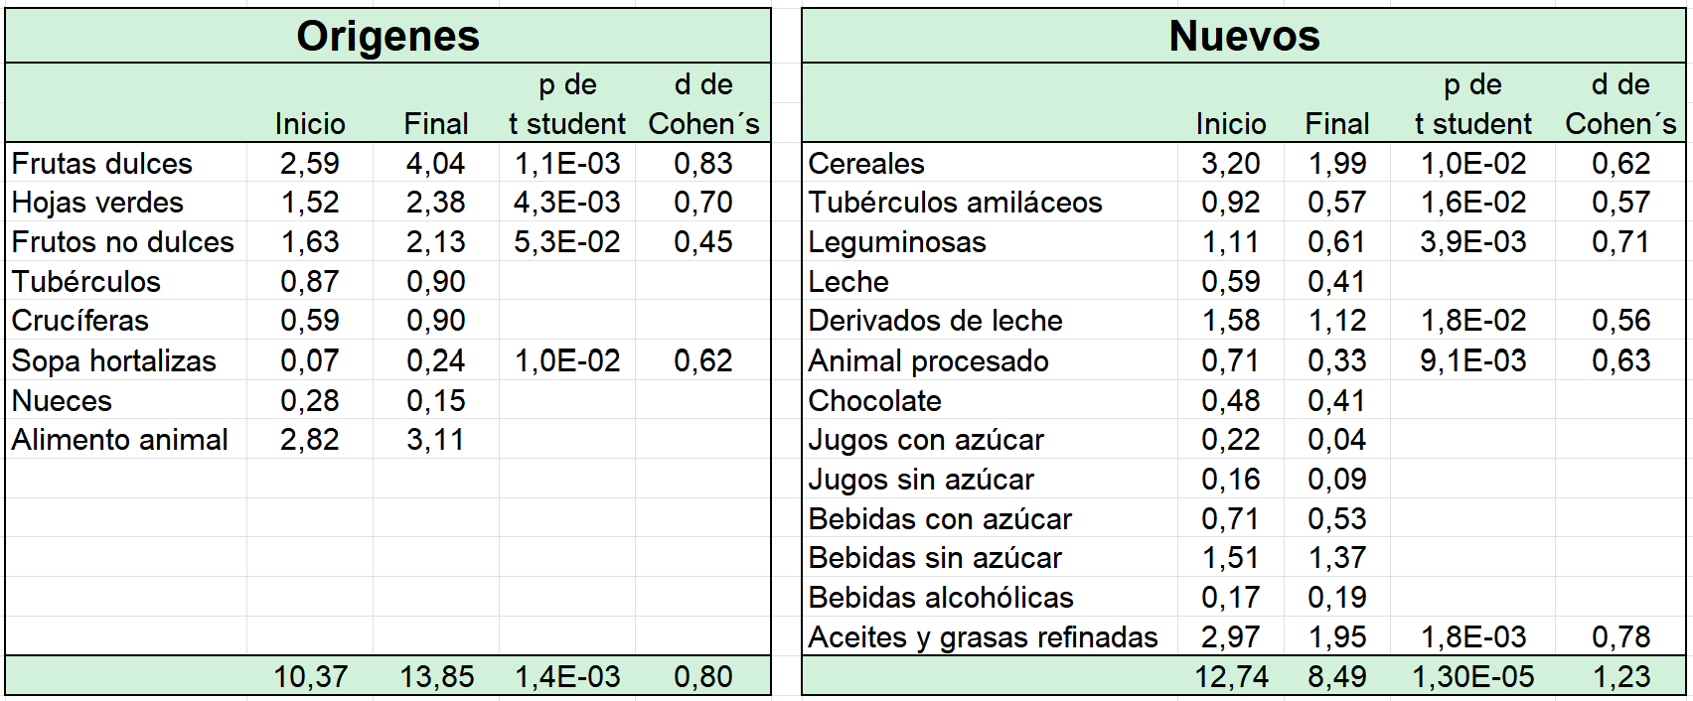

In addition, a significant change in CG was observed for each participant, with the mean decreasing from 53.9 to 23.1 g/meal (p = 6.2 × 10⁻⁸ and Cohen’s d = 1.72).
With regard to physical activity, a statistically significant difference was observed only for the total time spent on each activity (walking / light activity / vigorous activity), which increased from 185.1 to 241.5 minutes per week (p = 0.0051 and Cohen’s d = 0.67), exceeding the 150 minutes per week recommended by the WHO.
Table 3 shows the anthropometric variations

Table 3: Anthropometric Variations
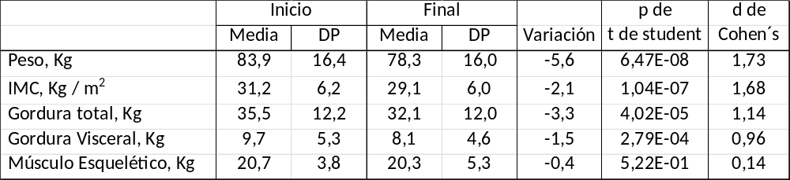

Figure 3 shows the weekly changes in average weight for the half of the participants who lost weight more quickly (-7.9 kg) and the half who lost weight more slowly (-3.2 kg), in accordance with the guidelines that each participant chooses their own rate of weight loss.

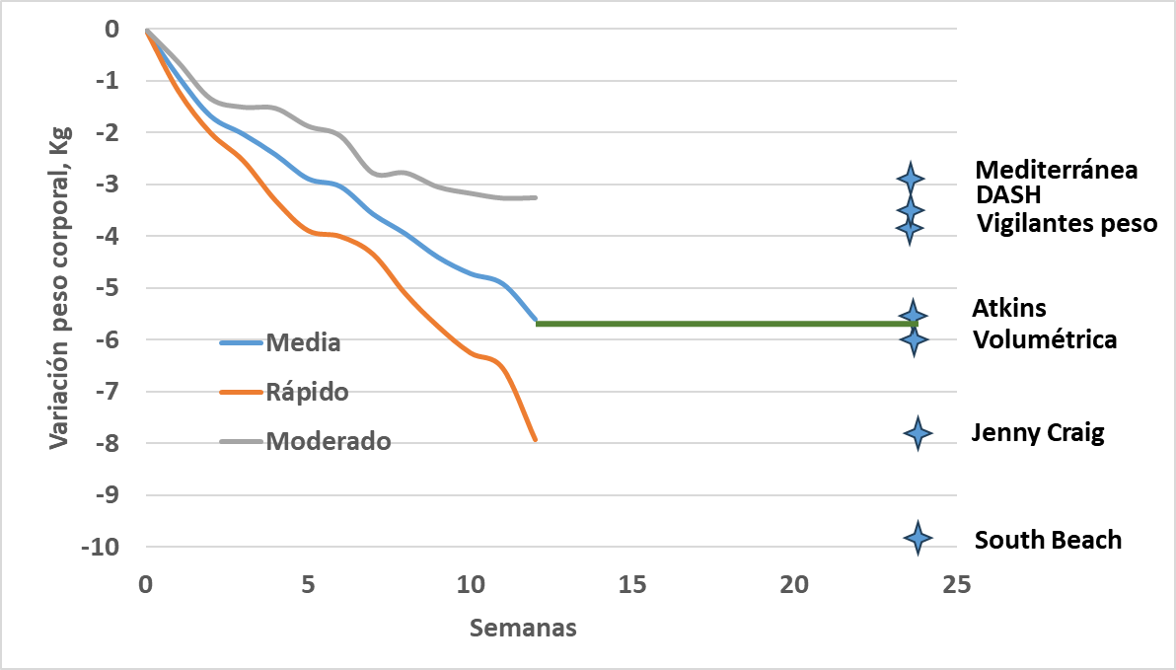
Figure 3: Weight Loss Curve

According to a recent meta-analysis that compared 14 programs over a six-month period, the ones that stood out the most were: South Beach, losing 9.9 kg; Jenny Craig, 7.8 kg; Volumétrica, 6 kg; and Atkins, 5.5 kg. [141]. With an average weight loss of 5.6 kg achieved in half the time (3 months), this program ranks among the best in the world.

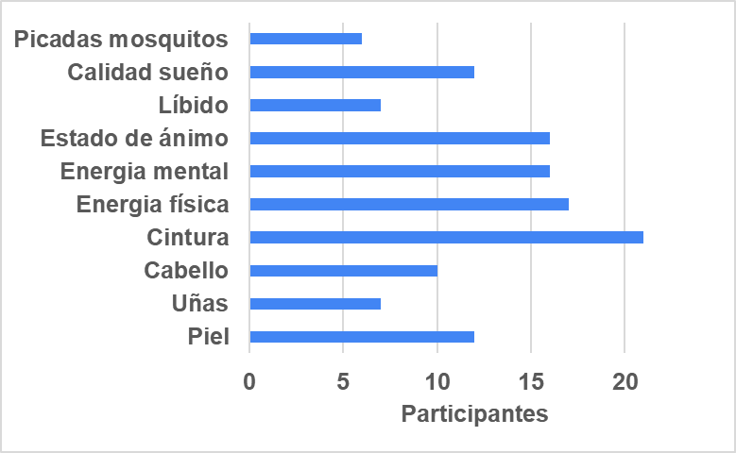
Figure 4: Perceived improvements in health in general

Figure 4 shows the number of participants who reported improvements in their overall health. No one mentioned any damage. Figure 5 shows the number of participants who reported improvements in their preexisting health conditions. Only one case reported worsening constipation, with suspected causes unrelated to the program. Several participants reported improvements in self-esteem and immunity, as well as a reduction in feelings of guilt. During the first and second weeks, some participants reported mild headaches, which were attributed to a blood glucose level well below the recommended range. After the treatment, the symptoms disappeared.
There was a wide range in the number of videos viewed. 90% found the videos clear and relevant. Sixty percent considered participation in the weekly meetings to be “very useful,” and nearly 50 percent felt that the Forum helped with the process. Everyone said they would recommend the program.

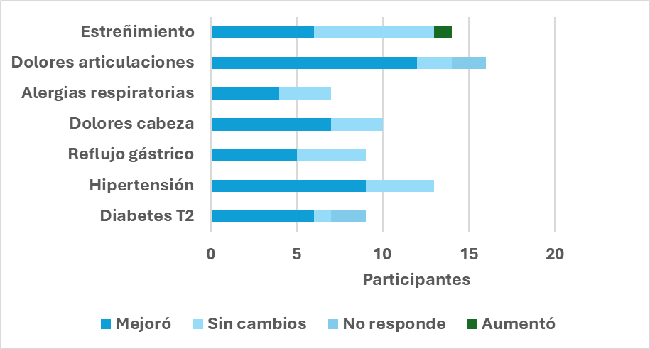
Figure 5: Perceived improvements in preexisting health conditions

Discussion and Conclusions

Changes in eating habits and physical activity confirm a shift toward a more mindful and intuitive approach, which is key to losing weight quickly and healthily. The virtual tools (initial assessment, support platform, videos, modules, forum, weekly meetings, WhatsApp conversations) and the use of psychological approaches (defining the big picture, the spiral of continuous improvement, CBT, mindfulness, and combating stress and the cycle of restrictions-frustrations-guilt) worked in holistic synergy to help participants achieve their goals.
Moderate Caloric Density
Counting calories versus moderating calorie density is a recent debate [142,143].
- Counting calories provides an accurate picture of energy balance, which is useful for those seeking detailed control, but it requires discipline and can lead to stress or obsession, in addition to not taking into account factors such as satiety and hormonal responses.
- Choosing foods with low calorie density allows you to eat larger portions, increases feelings of fullness, and promotes more intuitive eating, although it can lead to monotony.
Table 2 confirms that the strategy of moderating caloric density, as supported by Figure 1, helped reduce calorie intake, as one might expect.
Choose Nutritional Density
Table 2 also confirms the increase in consumption of foods with higher nutritional density, as shown in Figure 2.
Since several participants reported difficulty estimating portion sizes in the dietary habits questionnaire, it was not possible to quantify the variation in calorie and essential nutrient intake.
Moderate CG
After decades of debate over the benefits of reducing fat versus limiting carbohydrates, current evidence suggests that, in the long term (12 to 24 months), there are no significant differences. In the short term (6 to 12 months), moderate-carbohydrate diets appear to be more effective. The most important thing is to maintain a calorie deficit and stick to the program, regardless of the type of dietary restriction [144].
The program evaluated adopted a hybrid approach: prioritizing low-calorie-density foods (which includes reducing fats and other sources of calories) and limiting total fat intake to about 10 g. Changes in dietary habits (Table 2) and anthropometric results (Table 3) confirm the effectiveness of this approach.
Participants had no difficulty adopting this hybrid approach, in contrast to what has been reported in the literature, which indicates that extremely low-carbohydrate diets (ketogenic and carnivore) are difficult to follow and pose health risks [145].
This program was highly effective in alleviating the symptoms of most participants with type 2 diabetes, as shown in Figure 5, a finding that is widely supported in the literature [146].
It is important to note that there is significant variation in the glycemic response from one person to another and from one meal to another in the same individual, even for the same glycemic index (GI). People with higher levels of insulin resistance show more pronounced responses [147]. The state of the gut microbiome alters the response [147]. In people with a morning chronotype, the response to the same CG is greater at night than in the morning [148]. The food matrix (fiber, fat, protein) [149] and the order in which macronutrients are consumed also has an influence [150].
Moderate physical activity and enjoyable
The metabolic and psychological benefits of physical activity are numerous [151].
However, exercise reaches its full potential when combined with nutritional, behavioral, and healthy lifestyle interventions [151].
The program’s recommendations to engage in moderate and enjoyable physical activity achieved their goal, reducing sedentary behavior and increasing the number of participants who engaged in at least 150 minutes of physical activity per week, as recommended by the World Health Organization [12].
Anthropometric changes: Weight
As shown in Figure 3, the program's performance ranks it among the best programs worldwide
Anthropometric changes: Visceral fat
The program promoted lifestyle changes for which there is evidence of their benefits in reducing visceral fat, such as: physical activity [152,153]. a low-calorie diet [154,155], adequate protein intake [156,157], low glycemic load [158] and an anti-inflammatory diet [158], which explains why virtually all participants reduced their visceral fat, by an average of 1.5 kg
Anthropometric changes: Skeletal Muscles
Bioimpedance results show an average increase of 1% in the percentage of skeletal muscle. However, when viewed in context, along with the total weight loss, we find that there was a non-significant average reduction of 0.4 kg, as shown in Table 3. It is important to note that when switching from a high-carbohydrate diet to one with moderate carbohydrate content, a reduction in muscle and liver glycogen (and bound water) is to be expected. Since the bioimpedance scale does not distinguish between muscle mass and glycogen, it is not possible to draw a reliable conclusion from the measurements.
Improvements Beyond Weight
Several authors point out that rapid weight loss (> 5 to 10% in less than six months) is associated with substantial health risks [159,160], including:
- Nutritional: pale skin, weakness, fatigue, hair loss, unusual cravings, constipation, depression, numbness or tingling in the joints, difficulty concentrating, among others (93),
- Psychological: irritability, fatigue, hunger, depression, anxiety, compulsive eating, and obsession with food [159],
- Physical: headaches, dizziness, constipation, menstrual irregularities, hair loss, and loss of muscle mass [161],
- Sleep: poor quality [162].
Participants lost an average of 6.8% of their body weight in just 3 months, with none of the associated risks observed. On the contrary, as shown in Figures 4 and 5, significant perceived improvements were observed in both overall health and preexisting health problems.
Holistic Approach
Traditional diets and weight-loss programs focus primarily on dietary education and physical activity. The mental aspect is often overlooked. This study helps provide evidence regarding the importance of incorporating psychological tools, such as: defining a “big picture” [163,164]; a spiral of continuous improvement [163,165]; mindfulness [166]; cognitive-behavioral therapy [167]; stress management [168]; breaking the cycle of restrictions – frustrations – guilt [169] and reducing the forgetting curve [136].
Customization
The value of adopting a personalized approach, as opposed to a “one-size-fits-all” model, was demonstrated [170]. Weekly meetings, the Forum, and one-on-one interactions would help identify individual characteristics and needs, allowing for personalized approaches to achieve better results—such as lacto-ovo-vegetarianism, lipedema, congenital cognitive impairments, and self-sabotage patterns, among others.
Dropout Rate
The dropout rate for this study was 14%, a notable result when compared to systematic reviews that report rates ranging from 20% to 80% [171–173].
Several participants expressed at various times their intention to drop out of the program, due to skepticism, feelings of being unique (“I’m different”), limiting beliefs, a perception of stagnation (I stopped losing weight), a slow metabolism, misinterpretation of the scale, lack of time, stress, depression, feelings of guilt, cognitive distortions, travel, illness, accidents, and work-related exhaustion (“burnout”).
The support tools and holistic approach were essential for identifying and addressing these situations early on, while maintaining a high level of motivation, commitment, and performance, along with a low dropout rate.
Cost-Effectiveness
The Incremental Cost-Effectiveness Ratio (ICER) is used to compare two intervention programs; it is defined as the difference in costs divided by the difference in the effect achieved by both programs [174,175]. Digital weight-loss interventions show evidence of being cost-effective compared to in-person care [174,175].
Without attempting to provide a detailed analysis, the findings of this study show that it is highly effective for weight loss and improving health. At the same time, the cost estimate was lower than initially projected. This result suggests that this program has the potential to establish itself as a promising alternative in the field of healthy weight loss services, while also being cost-effective.
Conclusions
The results of this study confirm that the program under evaluation achieved its overall goal of promoting healthy weight loss.
The rapid and significant changes in dietary habits and physical activity, the evident improvements in health, the high effectiveness compared to other programs, the ease of customization, the low dropout rate, and the good cost-effectiveness ratio show that the program has the characteristics to rank among the most effective and innovative globally, benefiting both those who wish to lose weight and the professionals who implement it.
Among the limitations were: 1) bioimpedance analysis proved difficult to use for assessing changes in muscle mass; 2) the dietary habits questionnaire did not provide reliable data for assessing changes in calorie and essential nutrient intake; and 3) the results regarding health and well-being were based on participants’ perceptions, which poses a risk of subjective bias. These are areas worth exploring in the future.
Given the chronic nature of obesity and the challenges associated with weight maintenance, it is worthwhile to conduct follow-up longitudinal studies with participants to assess the long-term sustainability of the results achieved.

Acknowledgments: To my wife, for her unconditional support. To Simone Ushikusa (Nutritionist) and Daniel Vieira (Psychologist) for their support in developing the support platform.

Conflict of interest:
The author states that he is interested in launching a startup based on the results presented in this study. This initiative did not influence the study design, data collection, or data analysis; the research was conducted independently, and all procedures, methodological decisions, and results accurately reflect the original data.

References

[1] Boutari C, Mantzoros CS. A 2022 update on the epidemiology of obesity and a call to action: as its twin COVID-19 pandemic appears to be receding, the obesity and dysmetabolism pandemic continues to rage on. Metabolism 2022;133:155217. https://doi.org/10.1016/j.metabol.2022.155217.
[2] WHO. Obesity and overweight. World Health Organizaton - Fact Sheets 2024. https://www.who.int/news-room/fact-sheets/detail/obesity-and-overweight (accessed June 18, 2024).
[3] Ministério da Saúde. Secretaria de Vigilância em Saúde e Ambiente. Departamento de Análise Epidemiológica e Vigilância de Doenças Não Transmissíveis. Vigitel Brasil 2023: vigilância de fatores de risco e proteção para doenças crônicas por inquérito telefônico: estimativas sobre frequência e distribuição sociodemográfica de fatores de risco e proteção para doenças crônicas nas capitais dos 26 estados brasileiros e no Distrito Federal em 2023. Brasilia: 2023.
[4] Ward ZJ, Bleich SN, Long MW, Gortmaker SL. Association of body mass index with health care expenditures in the United States by age and sex. PLoS One 2021;16:e0247307. https://doi.org/10.1371/journal.pone.0247307.
[5] World Obesity. Global Obesity Observatory - Interactive maps. World Obesity 2019. https://data.worldobesity.org/region/who-americas-region-3/#data_prevalence (accessed February 8, 2025).
[6] Kloock S, Ziegler CG, Dischinger U. Obesity and its comorbidities, current treatment options and future perspectives: Challenging bariatric surgery? Pharmacol Ther 2023;251:108549. https://doi.org/10.1016/j.pharmthera.2023.108549.
[7] Pontzer H, Wood BM, Raichlen DA. Hunter‐gatherers as models in public health. Obesity Reviews 2018;19:24–35. https://doi.org/10.1111/obr.12785.
[8] Alt KW, Al-Ahmad A, Woelber JP. Nutrition and Health in Human Evolution–Past to Present. Nutrients 2022;14:3594. https://doi.org/10.3390/nu14173594.
[9] Gurven M, Kaplan H. Longevity Among Hunter‐ Gatherers: A Cross‐Cultural Examination. Popul Dev Rev 2007;33:321–65. https://doi.org/10.1111/j.1728-4457.2007.00171.x.
[10] Pontzer H, Raichlen DA, Wood BM, Mabulla AZP, Racette SB, Marlowe FW. Hunter-Gatherer Energetics and Human Obesity. PLoS One 2012;7:e40503. https://doi.org/10.1371/journal.pone.0040503.
[11] Carrera-Bastos P, Fontes, O’Keefe, Lindeberg, Cordain. The western diet and lifestyle and diseases of civilization. Research Reports in Clinical Cardiology 2011:15. https://doi.org/10.2147/RRCC.S16919.
[12] Bull FC, Al-Ansari SS, Biddle S, Borodulin K, Buman MP, Cardon G, et al. World Health Organization 2020 guidelines on physical activity and sedentary behaviour. Br J Sports Med 2020;54:1451–62. https://doi.org/10.1136/bjsports-2020-102955.
[13] WHO. Global status report on physical activity 2022. Geneva: 2022.
[14] Segal Y, Gunturu S. Psychological Issues Associated With Obesity. StatPearls Publishing; 2025.
[15] Sarwer DB, Polonsky HM. The Psychosocial Burden of Obesity. Endocrinol Metab Clin North Am 2016;45:677–88. https://doi.org/10.1016/j.ecl.2016.04.016.
[16] van Egmond LT, Meth EMS, Engström J, Ilemosoglou M, Keller JA, Vogel H, et al. Effects of acute sleep loss on leptin, ghrelin, and adiponectin in adults with healthy weight and obesity: A laboratory study. Obesity 2023;31:635–41. https://doi.org/10.1002/oby.23616.
[17] SBCBM. 60% dos pacientes com obesidade sofrem de distúrbio psiquiátrico. SBCBM - Sociedade Brasileira de Cirurgia Bariátrica e Metabólica 2022. https://sbcbm.org.br/60-dos-pacientes-com-obesidade-sofrem-de-disturbio-psiquiatrico (accessed July 9, 2025).
[18] Zielińska M, Łuszczki E, Dereń K. Dietary Nutrient Deficiencies and Risk of Depression (Review Article 2018–2023). Nutrients 2023;15:2433. https://doi.org/10.3390/nu15112433.
[19] Vafiadis D. How Excess Weight Impacts Our Mental and Emotional Health. NCOA - National Council on Aging 2024. https://www.ncoa.org/article/how-excess-weight-impacts-our-mental-and-emotional-health (accessed July 1, 2024).
[20] Kedar Y, Kedar G, Barkai R. The influence of smoke density on hearth location and activity areas at Lower Paleolithic Lazaret Cave, France. Sci Rep 2022;12:1469. https://doi.org/10.1038/s41598-022-05517-z.
[21] Janiak MC. Of starch and spit. Elife 2019;8. https://doi.org/10.7554/eLife.47523.
[22] Davidson B, Maciver J, Lessard E, Connors K. Meat lipid profiles: a comparison of meat from domesticated and wild Southern African animals. In Vivo 2011;25:197–202.
[23] Crane-Kramer G, Buckberry J. Changes in health with the rise of industry. Int J Paleopathol 2023;40:99–102. https://doi.org/10.1016/j.ijpp.2022.12.005.
[24] Azzam A. Is the world converging to a ‘Western diet’? Public Health Nutr 2021;24:309–17. https://doi.org/10.1017/S136898002000350X.
[25] Codex Alimentarius Commission. General Standard for Food Additives (CODEX STAN 192-1995, revised 2024). Roma: 2025.
[26] Babbel J, Ramos C, Wangberg H, Luskin K, Simon R. Adverse reactions to food additives. Journal of Food Allergy 2021;3:8–23. https://doi.org/10.2500/jfa.2021.3.210004.
[27] Rego RA, Vialta A, Ceribelli Madi LF. Biscoitos Industrializados: Nutrição e indulgencia na cultura alimentar. São Paulo: 2020.
[28] British Food: A History. A Very Brief History of Bread. British Food: A History 2012. https://britishfoodhistory.com/2012/01/15/our-daily-bread/ (accessed April 15, 2025).
[29] Cruz EP. Dia Mundial do Pão: conheça um pouco da história do produto no Brasil. AgenciaBrasil 2019. https://agenciabrasil.ebc.com.br/geral/noticia/2019-10/dia-mundial-do-pao-conheca-um-pouco-da-historia-do-produto-no-brasil (accessed April 15, 2025).
[30] Amback A. A historia do macarrão no Brasil. São Paulo: 2014.
[31] Pereira A da S. A evolução da cultura da batata no Brasil. Hortic Bras 2011;29.
[32] Ministerio da Saúde. Saúde promove conscientização sobre o consumo de açúcar em webinário. GovBr 2023. https://www.gov.br/saude/pt-br/assuntos/noticias/2022/janeiro/saude-promove-conscientizacao-sobre-o-consumo-de-acucar-em-webinario (accessed February 17, 2025).
[33] Kemps E, Tiggemann M, Tuscharski A. The effect of television advertising on soft drink consumption: Individual vulnerabilities in approach bias and inhibitory control. Appetite 2021;165:105300. https://doi.org/10.1016/j.appet.2021.105300.
[34] Our World in Data. Daily per capita fat supply, 1961 to 2021 2025. https://ourworldindata.org/food-supply#all-charts (accessed February 17, 2025).
[35] Diamond A. A Crispy, Salty, American History of Fast Food. Smithsonian Magazine 2019. https://www.smithsonianmag.com/history/crispy-salty-american-history-fast-food-180972459/ (accessed April 14, 2025).
[36] Rego RA, Vialta A, Madi LFC. Bolos industrializados : socialização, prazer е nutrição . São Paulo: ABIMAPI; 2021.
[37] Andrich M. Surgiu de repente, flocos de milho. Revista Brasileira de Administração 2017. https://revistarba.org.br/de-repente-flocos-de-milho (accessed April 15, 2025).
[38] APUBRA - Associação Pizzarias Unidas do Brasil. Historia da pizza 2025. https://apubra.org.br/mapa-site/historia-pizza (accessed April 15, 2025).
[39] Pereira JA. Cultura do arroz no Brasil - Subsídios para a sua historia. 1a. Edição. Teresina - PI: EMBRAPA; 2002.
[40] USDA. FoodData Central. US Department of Agriculture - Agricultural Research Services 2023. https://fdc.nal.usda.gov/ (accessed March 26, 2024).
[41] Mawer R. How does calorie density affect weight? HealthLine 2019. https://www.healthline.com/nutrition/calorie-density (accessed June 23, 2024).
[42] The Lancet. The Double Burden of Malnutrition - Executive summary. The Lancet 2019.
[43] Astrup A, Bügel S. Overfed but undernourished: recognizing nutritional inadequacies/deficiencies in patients with overweight or obesity. Int J Obes 2019;43:219–32. https://doi.org/10.1038/s41366-018-0143-9.
[44] Furman D, Campisi J, Verdin E, Carrera-Bastos P, Targ S, Franceschi C, et al. Chronic inflammation in the etiology of disease across the life span. Nat Med 2019;25:1822–32. https://doi.org/10.1038/s41591-019-0675-0.
[45] Silva P, Araújo R, Lopes F, Ray S. Nutrition and Food Literacy: Framing the Challenges to Health Communication. Nutrients 2023;15:4708. https://doi.org/10.3390/nu15224708.
[46] Vasiloglou MF, Fletcher J, Poulia K-A. Challenges and Perspectives in Nutritional Counselling and Nursing: A Narrative Review. J Clin Med 2019;8:1489. https://doi.org/10.3390/jcm8091489.
[47] Deslippe AL, Soanes A, Bouchaud CC, Beckenstein H, Slim M, Plourde H, et al. Barriers and facilitators to diet, physical activity and lifestyle behavior intervention adherence: a qualitative systematic review of the literature. International Journal of Behavioral Nutrition and Physical Activity 2023;20:14. https://doi.org/10.1186/s12966-023-01424-2.
[48] Nguyen KA, De Villiers A, Fourie JM, Hendricks M. Challenges to implementing the food-based dietary guidelines in the South African primary school curriculum: a qualitative study exploring the perceptions of principals and curriculum advisors. South African Journal of Clinical Nutrition 2017;30:15–20. https://doi.org/10.1080/16070658.2016.1230971.
[49] Persoskie A, Hennessy E, Nelson WL. US Consumers’ Understanding of Nutrition Labels in 2013: The Importance of Health Literacy. Prev Chronic Dis 2017;14:170066. https://doi.org/10.5888/pcd14.170066.
[50] Oostenbach LH, Slits E, Robinson E, Sacks G. Systematic review of the impact of nutrition claims related to fat, sugar and energy content on food choices and energy intake. BMC Public Health 2019;19:1296. https://doi.org/10.1186/s12889-019-7622-3.
[51] Mehrtash F, Manson JE. The 5 A’s Approach to Promoting Nutrition Counseling in Primary Care. J Prim Care Community Health 2025;16. https://doi.org/10.1177/21501319251338566.
[52] Bruins M, Bird J, Aebischer C, Eggersdorfer M. Considerations for Secondary Prevention of Nutritional Deficiencies in High-Risk Groups in High-Income Countries. Nutrients 2018;10:47. https://doi.org/10.3390/nu10010047.
[53] National Academy of Sciences. Dietary Reference Intakes Summary Tables. National Library of Medicine 2019. https://www.ncbi.nlm.nih.gov/books/NBK545442/ (accessed June 23, 2025).
[54] Lawrence M. Fundamentals of a healthy and sustainable diet. Nutr J 2024;23:150. https://doi.org/10.1186/s12937-024-01049-6.
[55] Petre A, Johnson ML. What are polyphenols? Types, Benefits, and Food Sources. Healthline 2023. https://www.healthline.com/nutrition/polyphenols (accessed April 19, 2025).
[56] Plamada D, Vodnar DC. Polyphenols—gut microbiota interrelationship: A transition to a new generation of prebiotics. Nutrients 2022;14. https://doi.org/10.3390/nu14010137.
[57] Drewnowski A, Fulgoni VL. Nutrient density: principles and evaluation tools. Am J Clin Nutr 2014;99:1223S-1228S. https://doi.org/10.3945/ajcn.113.073395.
[58] The University of Sydney. About GI. Glycemix Index 2025. https://glycemicindex.com/ (accessed February 12, 2025).
[59] Coyle D, Kubala J. A Beginner´s guide to the Low Glycemic Diet. Healthline 2023. https://www.healthline.com/nutrition/low-glycemic-diet (accessed February 12, 2025).
[60] Cordain L, Eaton SB, Sebastian A, Mann N, Lindeberg S, Watkins BA, et al. Origins and evolution of the Western diet: health implications for the 21st century1,2. Am J Clin Nutr 2005;81:341–54. https://doi.org/10.1093/ajcn.81.2.341.
[61] Villines Z, Bell AM. How insulin and glucagon regulate blood sugar. MedicalNewsToday 2023. https://www.medicalnewstoday.com/articles/316427 (accessed June 21, 2024).
[62] Konner M, Eaton SB. Hunter‐gatherer diets and activity as a model for health promotion: Challenges, responses, and confirmations. Evolutionary Anthropology: Issues, News, and Reviews 2023;32:206–22. https://doi.org/10.1002/evan.21987.
[63] Della Corte KA, Della Corte D, Titensor S, Yang B, Liu S. Development of a national database for dietary glycemic index and load for nutritional epidemiologic studies in the United States. Am J Clin Nutr 2024;120:380–8. https://doi.org/10.1016/j.ajcnut.2024.06.001.
[64] Gardner CD, Hauser ME. Food Revolution. Am J Lifestyle Med 2017;11:387–96. https://doi.org/10.1177/1559827617696289.
[65] National Research Council (US) Committee on Identifying and Assessing Unintended Effects of Genetically Engineered Foods on Human Health. Safety of Genetically Engineered Foods: Approaches to Assessing Unintended Health Effects. Washington (DC): National Academy Press (US); 2004.
[66] Campolim CM, Schimenes BC, Veras MM, Kim Y-B, Prada PO. Air pollution accelerates the development of obesity and Alzheimer’s disease: the role of leptin and inflammation - a mini-review. Front Immunol 2024;15. https://doi.org/10.3389/fimmu.2024.1401800.
[67] Khalil WJ, Akeblersane M, Khan AS, Moin ASM, Butler AE. Environmental Pollution and the Risk of Developing Metabolic Disorders: Obesity and Diabetes. Int J Mol Sci 2023;24:8870. https://doi.org/10.3390/ijms24108870.
[68] Baudry J, Rebouillat P, Samieri C, Berlivet J, Kesse-Guyot E. Dietary pesticide exposure and non-communicable diseases and mortality: a systematic review of prospective studies among adults. Environmental Health 2023;22:76. https://doi.org/10.1186/s12940-023-01020-8.
[69] Yu M, Xie J, Liu Y. How air pollution influences the difference between overweight and obesity: a comprehensive analysis of direct and indirect correlations. Front Public Health 2024;12. https://doi.org/10.3389/fpubh.2024.1403197.
[70] Luo C, Wei T, Jiang W, Yang Y, Zhang M-X, Xiong C-L, et al. The association between air pollution and obesity: an umbrella review of meta-analyses and systematic reviews. BMC Public Health 2024;24:1856. https://doi.org/10.1186/s12889-024-19370-4.
[71] Lee J, Park SK. Associations of heavy metals and urinary sodium excretion with obesity in adults: A cross-sectional study from Korean Health Examination and Nutritional Survey. PLoS One 2025;20:e0317190. https://doi.org/10.1371/journal.pone.0317190.
[72] Pinos H, Carrillo B, Merchán A, Biosca-Brull J, Pérez-Fernández C, Colomina MT, et al. Relationship between Prenatal or Postnatal Exposure to Pesticides and Obesity: A Systematic Review. Int J Environ Res Public Health 2021;18:7170. https://doi.org/10.3390/ijerph18137170.
[73] Alvarado-Calvo A, Alvarado-Rodríguez Y, Cruz-Mora K, Mora-Jiménez J, Arguedas-Chacón S, Zavaleta-Monestel E. Trends and Association of Environmental Exposure and Climate Change with Non-Communicable Diseases in Latin America. Healthcare 2025;13:1653. https://doi.org/10.3390/healthcare13141653.
[74] Brennan D, Turley RK, Correa Marquez RR. When Your Weight Gain Is Caused by Medicine. University of Rochester, Medical Center 2025. https://www.urmc.rochester.edu/encyclopedia/content?contenttypeid=56&contentid=dm300 (accessed February 5, 2025).
[75] Herrera RJ, Garcia-Bertrand R. The Agricultural Revolutions. Ancestral DNA, Human Origins, and Migrations 2018:475–509. https://doi.org/10.1016/B978-0-12-804124-6.00013-6.
[76] Szukiewicz D. Molecular Mechanisms for the Vicious Cycle between Insulin Resistance and the Inflammatory Response in Obesity. Int J Mol Sci 2023;24:9818. https://doi.org/10.3390/ijms24129818.
[77] Shoelson SE. Inflammation and insulin resistance. Journal of Clinical Investigation 2006;116:1793–801. https://doi.org/10.1172/JCI29069.
[78] Mazidi M, Gao H, Kengne AP. Inflammatory Markers Are Positively Associated with Serum trans -Fatty Acids in an Adult American Population. J Nutr Metab 2017;2017:1–6. https://doi.org/10.1155/2017/3848201.
[79] DiNicolantonio JJ, O’Keefe J. The Importance of Maintaining a Low Omega-6/Omega-3 Ratio for Reducing the Risk of Autoimmune Diseases, Asthma, and Allergies. Mo Med 2021;118:453–9.
[80] Chai W, Morimoto Y, Cooney R V., Franke AA, Shvetsov YB, Le Marchand L, et al. Dietary Red and Processed Meat Intake and Markers of Adiposity and Inflammation: The Multiethnic Cohort Study. J Am Coll Nutr 2017;36:378–85. https://doi.org/10.1080/07315724.2017.1318317.
[81] Wang HJ. Alcohol, inflammation, and gut-liver-brain interactions in tissue damage and disease development. World J Gastroenterol 2010;16:1304. https://doi.org/10.3748/wjg.v16.i11.1304.
[82] Bellanti JA, Settipane RA. Inflammation and allergic disease: An irrefutable combination. Allergy Asthma Proc 2019;40:1–3. https://doi.org/10.2500/aap.2019.40.4198.
[83] Potrykus M, Czaja-Stolc S, Stankiewicz M, Kaska Ł, Małgorzewicz S. Intestinal Microbiota as a Contributor to Chronic Inflammation and Its Potential Modifications. Nutrients 2021;13:3839. https://doi.org/10.3390/nu13113839.
[84] Hess JM, Stephensen CB, Kratz M, Bolling BW. Exploring the Links between Diet and Inflammation: Dairy Foods as Case Studies. Advances in Nutrition 2021;12:1S-13S. https://doi.org/10.1093/advances/nmab108.
[85] Philip A, White ND. Gluten, Inflammation, and Neurodegeneration. Am J Lifestyle Med 2022;16:32–5. https://doi.org/10.1177/15598276211049345.
[86] Raoul P, Cintoni M, Palombaro M, Basso L, Rinninella E, Gasbarrini A, et al. Food Additives, a Key Environmental Factor in the Development of IBD through Gut Dysbiosis. Microorganisms 2022;10:167. https://doi.org/10.3390/microorganisms10010167.
[87] Liu Y, Zhang Z, Han D, Zhao Y, Yan X, Cui S. Association between environmental chemicals co-exposure and peripheral blood immune-inflammatory indicators. Front Public Health 2022;10. https://doi.org/10.3389/fpubh.2022.980987.
[88] Roth‐Walter F, Berni Canani R, O’Mahony L, Peroni D, Sokolowska M, Vassilopoulou E, et al. Nutrition in chronic inflammatory conditions: Bypassing the mucosal block for micronutrients. Allergy 2024;79:353–83. https://doi.org/10.1111/all.15972.
[89] Liu Y-Z, Wang Y-X, Jiang C-L. Inflammation: The Common Pathway of Stress-Related Diseases. Front Hum Neurosci 2017;11. https://doi.org/10.3389/fnhum.2017.00316.
[90] Burini RC, Anderson E, Durstine JL, Carson JA. Inflammation, physical activity, and chronic disease: An evolutionary perspective. Sports Medicine and Health Science 2020;2:1–6. https://doi.org/10.1016/j.smhs.2020.03.004.
[91] Ma W, Nguyen LH, Song M, Wang DD, Franzosa EA, Cao Y, et al. Dietary fiber intake, the gut microbiome, and chronic systemic inflammation in a cohort of adult men. Genome Med 2021;13:102. https://doi.org/10.1186/s13073-021-00921-y.
[92] Elisia I, Lam V, Cho B, Hay M, Li MY, Yeung M, et al. The effect of smoking on chronic inflammation, immune function and blood cell composition. Sci Rep 2020;10:19480. https://doi.org/10.1038/s41598-020-76556-7.
[93] Liu Z, Lu Y, Zhong K, Wang C, Xu X. The associations between endocrine disrupting chemicals and markers of inflammation and immune responses: A systematic review and meta-analysis. Ecotoxicol Environ Saf 2022;234:113382. https://doi.org/10.1016/j.ecoenv.2022.113382.
[94] Mullington JM, Simpson NS, Meier-Ewert HK, Haack M. Sleep loss and inflammation. Best Pract Res Clin Endocrinol Metab 2010;24:775–84. https://doi.org/10.1016/j.beem.2010.08.014.
[95] De la Iglesia R, Loria-Kohen V, Zulet M, Martinez J, Reglero G, Ramirez de Molina A. Dietary Strategies Implicated in the Prevention and Treatment of Metabolic Syndrome. Int J Mol Sci 2016;17:1877. https://doi.org/10.3390/ijms17111877.
[96] Castruita PA, Piña-Escudero SD, Rentería ME, Yokoyama JS. Genetic, Social, and Lifestyle Drivers of Healthy Aging and Longevity. Curr Genet Med Rep 2022;10:25–34. https://doi.org/10.1007/s40142-022-00205-w.
[97] Steel N, Bauer-Staeb CMM, Ford JA, Abbafati C, Abdalla MA, Abdelkader A, et al. Changing life expectancy in European countries 1990–2021: a subanalysis of causes and risk factors from the Global Burden of Disease Study 2021. Lancet Public Health 2025;10:e172–88. https://doi.org/10.1016/S2468-2667(25)00009-X.
[98] Afzaal M, Saeed F, Shah YA, Hussain M, Rabail R, Socol CT, et al. Human gut microbiota in health and disease: Unveiling the relationship. Front Microbiol 2022;13. https://doi.org/10.3389/fmicb.2022.999001.
[99] Kendall M. Blood Sugar and Hunger: Decoding the Intimate Relationship. Optimizing Nutrition 2023. https://optimisingnutrition.com/blood-glucose-hunger-relationship/ (accessed February 14, 2025).
[100] Stevenson RJ, Boutelle K. Hunger, Satiety, and Their Vulnerabilities. Nutrients 2024;16:3013. https://doi.org/10.3390/nu16173013.
[101] Gibbons C, Hopkins M, Beaulieu K, Oustric P, Blundell JE. Issues in Measuring and Interpreting Human Appetite (Satiety/Satiation) and Its Contribution to Obesity. Curr Obes Rep 2019;8:77–87. https://doi.org/10.1007/s13679-019-00340-6.
[102] Chambers L, McCrickerd K, Yeomans MR. Optimising foods for satiety. Trends Food Sci Technol 2015;41:149–60. https://doi.org/10.1016/j.tifs.2014.10.007.
[103] Dericioglu D, Oldham S, Methven L, Shafat A, Clegg ME. Macronutrients effects on satiety and food intake in older and younger adults: A randomised controlled trial. Appetite 2023;189:106982. https://doi.org/10.1016/j.appet.2023.106982.
[104] Groenen M, Fyfe CL, Holtrop G, Horgan GW, Meek CL, Gribble F, et al. Investigation of mechanisms of protein induced satiety: meal structure and protein content effects on gastric emptying and gut hormone release. Proceedings of the Nutrition Society 2017;76:E30. https://doi.org/10.1017/S0029665117000866.
[105] Bu T, Sun Z, Pan Y, Deng X, Yuan G. Glucagon-Like Peptide-1: New Regulator in Lipid Metabolism. Diabetes Metab J 2024;48:354–72. https://doi.org/10.4093/dmj.2023.0277.
[106] Bray GA, Heisel WE, Afshin A, Jensen MD, Dietz WH, Long M, et al. The Science of Obesity Management: An Endocrine Society Scientific Statement. Endocr Rev 2018;39:79–132. https://doi.org/10.1210/er.2017-00253.
[107] Parmar R, Can A. Dietary Approaches to Obesity Treatment. 2024 Jan. Treasure Island (FL): StatPearls Publishing; 2023.
[108] Bjarnadottir A. 9 Popular Weight Loss Diets Reviewed 2019. https://www.healthline.com/nutrition/9-weight-loss-diets-reviewed (accessed July 6, 2025).
[109] Dedios MC, Esperato A, De-Regil LM, Peña-Rosas JP, Norris SL. Improving the adaptability of WHO evidence-informed guidelines for nutrition actions: results of a mixed methods evaluation. Implementation Science 2017;12:39. https://doi.org/10.1186/s13012-017-0571-2.
[110] Garone S, Stephens C. How to Read Nutrition Labels in 2019. Healthline 2020. https://www.healthline.com/health/food-nutrition/nutrition-labels (accessed February 8, 2025).
[111] Ganderats-Fuentes M, Morgan S. Front-of-Package Nutrition Labeling and Its Impact on Food Industry Practices: A Systematic Review of the Evidence. Nutrients 2023;15:2630. https://doi.org/10.3390/nu15112630.
[112] Benson T, Lavelle F, McCloat A, Mooney E, Bucher T, Egan B, et al. Are the Claims to Blame? A Qualitative Study to Understand the Effects of Nutrition and Health Claims on Perceptions and Consumption of Food. Nutrients 2019;11:2058. https://doi.org/10.3390/nu11092058.
[113] Jenson Gossard AK. Frequency of Counseling Sessions and Weight Loss Maintenance in a Commercial Lifestyle-Based Weight Management Program. San Jose State University, 2015. https://doi.org/10.31979/etd.vkd5-n73r.
[114] Wharton S, Lau DCW, Vallis M, Sharma AM, Biertho L, Campbell-Scherer D, et al. Obesity in adults: a clinical practice guideline. Can Med Assoc J 2020;192:E875–91. https://doi.org/10.1503/cmaj.191707.
[115] Campoverde Reyes KJ, Perez NP, Czepiel KS, Shaw AY, Stanford FC. Exploring Pediatric Obesity Training, Perspectives, and Management Patterns Among Pediatric Primary Care Physicians. Obesity 2021;29:159–70. https://doi.org/10.1002/oby.22990.
[116] Zhu B, Gostoli S, Benasi G, Patierno C, Petroni ML, Nuccitelli C, et al. The Role of Psychological Well-Being in Weight Loss: New Insights from a Comprehensive Lifestyle Intervention. International Journal of Clinical and Health Psychology 2022;22:100279. https://doi.org/10.1016/j.ijchp.2021.100279.
[117] Yu B, Chen Y, Qin H, Chen Q, Wang J, Chen P. Using multi-disciplinary teams to treat obese patients helps improve clinical efficacy: the general practitioner’s perspective. Am J Transl Res 2021;13:2571–80.
[118] Stanford FC, Tauqeer Z, Kyle TK. Media and Its Influence on Obesity. Curr Obes Rep 2018;7:186–92. https://doi.org/10.1007/s13679-018-0304-0.
[119] Bussan AJ. Lettuce Marketing Success. Growing Produce 2012. https://www.growingproduce.com/farm-management/lettuce-marketing-success/ (accessed February 10, 2025).
[120] Smith M. The impacts of social media on youth self-image. Loma Linda University - Health 2023. https://news.llu.edu/health-wellness/impacts-of-social-media-youth-self-image (accessed February 10, 2025).
[121] FGV. Uso de TI no Brasil: País tem mais de dois dispositivos digitais por habitante, revela pesquisa 2023. https://portal.fgv.br/noticias/uso-ti-brasil-pais-tem-mais-dois-dispositivos-digitais-habitante-revela-pesquisa (accessed July 6, 2025).
[122] Redação RBA. Pesquisa revela que brasileiros estão entre os que gastam mais tempo nas redes sociais 2023. https://www.redebrasilatual.com.br/blogs/blog-na-rede/pesquisa-revela-que-brasileiros-estao-entre-os-que-gastam-mais-tempo-nas-redes-sociais/ (accessed July 6, 2025).
[123] AWS - Amazon. ¿Qué es el 5G? Sitio AWS-Amazon n.d. https://aws.amazon.com/es/what-is/5g/ (accessed June 22, 2024).
[124] ReportLinker. E-healthcare in Brasil Market Overview 2023-2027. Lyon, France: 2023.
[125] Batista SA, Cupertino AFB, Cupertino AP, Botelho RBA, Pimentel J, Cartujano-Barrera F, et al. Nutrition and Diet Apps: Brazilian Panorama before and during the COVID-19 Pandemic. Nutrients 2023;15:3606. https://doi.org/10.3390/nu15163606.
[126] Eduardo A. O que é uma Rede de Apoio Mútuo? Idealist n.d. https://www.idealist.org/pt/days/o-que-e-uma-rede-de-apoio-mutuo (accessed April 25, 2025).
[127] Zaparolli D. La inteligencia artificial llega a la salud en Brasil. Revista Pesquisa FAPESP 2022. https://revistapesquisa.fapesp.br/es/la-inteligencia-artificial-llega-a-la-salud-en-brasil/ (accessed July 6, 2025).
[128] Kearns A, Moorhead A, Mulvenna M, Bond R. Assessing the Uses, Benefits, and Limitations of Digital Technologies Used by Health Professionals in Supporting Obesity and Mental Health Communication: Scoping Review. J Med Internet Res 2025;27:e58434. https://doi.org/10.2196/58434.
[129] Oliveira TW, Pereira PP da S, Fonseca LA, de Oliveira LML, Pereira DS, Neira CPD, et al. Use of Information and Communication Technologies among Adults in Weight Control: Systematic Review and Meta-Analysis. Nutrients 2022;14:4809. https://doi.org/10.3390/nu14224809.
[130] Michie S, van Stralen MM, West R. The behaviour change wheel: A new method for characterising and designing behaviour change interventions. Implementation Science 2011;6:42. https://doi.org/10.1186/1748-5908-6-42.
[131] Carden L, Wood W. Habit formation and change. Curr Opin Behav Sci 2018;20:117–22. https://doi.org/10.1016/j.cobeha.2017.12.009.
[132] Clear J. Atomic Habits: An Easy & Proven Way to Build Good Habits & Break Bad Ones. Avery; 2018.
[133] Lo Monaco G, Bonetto E. Social representations and culture in food studies. Food Research International 2019;115:474–9. https://doi.org/10.1016/j.foodres.2018.10.029.
[134] Coates PM, Bailey RL, Blumberg JB, El-Sohemy A, Floyd E, Goldenberg JZ, et al. The Evolution of Science and Regulation of Dietary Supplements: Past, Present, and Future. J Nutr 2024;154:2335–45. https://doi.org/10.1016/j.tjnut.2024.06.017.
[135] Harvard Health Publishing. The truth about fats: the good, the bad, and the in-between 2022. https://www.health.harvard.edu/staying-healthy/the-truth-about-fats-bad-and-good (accessed February 15, 2025).
[136] Murre JMJ, Chessa AG. Why Ebbinghaus’ savings method from 1885 is a very ‘pure’ measure of memory performance. Psychon Bull Rev 2023;30:303–7. https://doi.org/10.3758/s13423-022-02172-3.
[137] Wimmer GE, Poldrack RA. Reward learning and working memory: Effects of massed versus spaced training and post-learning delay period. Mem Cognit 2022;50:312–24. https://doi.org/10.3758/s13421-021-01233-7.
[138] Cirurgia.net. Preços de Dietas 2024. info.cirurgia.net/precos/dietas (accessed July 6, 2025).
[139] ELSA Brasil. DIE - Questionário ELSA_Onda 3 - Dieta. ELSA Brasil 2017:103–17. http://elsabrasil.org/pesquisadores/formularios-atividades-e-exames/ (accessed February 25, 2024).
[140] ELSA Brasil. EFI - Questionario ELSA_ONDA3 - Atividade Física. ELSA Brasil 2017:53–6. http://elsabrasil.org/pesquisadores/formularios-atividades-e-exames/ (accessed February 27, 2024).
[141] Ge L, Sadeghirad B, Ball GDC, da Costa BR, Hitchcock CL, Svendrovski A, et al. Comparison of dietary macronutrient patterns of 14 popular named dietary programmes for weight and cardiovascular risk factor reduction in adults: systematic review and network meta-analysis of randomised trials. BMJ 2020:m696. https://doi.org/10.1136/bmj.m696.
[142] Harvard. Stop counting calories. Harvard Health Publishing, Harvard Medical School 2010. https://www.health.harvard.edu/staying-healthy/stop-counting-calories?utm_source=chatgpt.com (accessed October 14, 2025).
[143] Ello-Martin JA, Roe LS, Ledikwe JH, Beach AM, Rolls BJ. Dietary energy density in the treatment of obesity: a year-long trial comparing 2 weight-loss diets. Am J Clin Nutr 2007;85:1465–77. https://doi.org/10.1093/ajcn/85.6.1465.
[144] Chawla S, Tessarolo Silva F, Amaral Medeiros S, Mekary R, Radenkovic D. The Effect of Low-Fat and Low-Carbohydrate Diets on Weight Loss and Lipid Levels: A Systematic Review and Meta-Analysis. Nutrients 2020;12:3774. https://doi.org/10.3390/nu12123774.
[145] Popiolek-Kalisz J. Ketogenic diet and cardiovascular risk – state of the art review. Curr Probl Cardiol 2024;49:102402. https://doi.org/10.1016/j.cpcardiol.2024.102402.
[146] Argiana V, Kanellos P, Eleftheriadou I, Tsitsinakis G, Perrea D, Tentolouris N. Low-Glycemic-Index/Load Desserts Decrease Glycemic and Insulinemic Response in Patients with Type 2 Diabetes Mellitus. Nutrients 2020;12:2153. https://doi.org/10.3390/nu12072153.
[147] Wu Y, Ehlert B, Metwally AA, Perelman D, Park H, Brooks AW, et al. Individual variations in glycemic responses to carbohydrates and underlying metabolic physiology. Nat Med 2025;31:2232–43. https://doi.org/10.1038/s41591-025-03719-2.
[148] Stutz B, Krueger B, Goletzke J, Jankovic N, Alexy U, Herder C, et al. Glycemic response to meals with a high glycemic index differs between morning and evening: a randomized cross-over controlled trial among students with early or late chronotype. Eur J Nutr 2024;63:1593–604. https://doi.org/10.1007/s00394-024-03372-4.
[149] Murillo S, Mallol A, Adot A, Juárez F, Coll A, Gastaldo I, et al. Culinary strategies to manage glycemic response in people with type 2 diabetes: A narrative review. Front Nutr 2022;9. https://doi.org/10.3389/fnut.2022.1025993.
[150] Shukla AP, Iliescu RG, Thomas CE, Aronne LJ. Food Order Has a Significant Impact on Postprandial Glucose and Insulin Levels. Diabetes Care 2015;38:e98–9. https://doi.org/10.2337/dc15-0429.
[151] Niezgoda N, Chomiuk T, Kasiak P, Mamcarz A, Śliż D. The Impact of Physical Activity on Weight Loss in Relation to the Pillars of Lifestyle Medicine—A Narrative Review. Nutrients 2025;17:1095. https://doi.org/10.3390/nu17061095.
[152] Chen X, He H, Xie K, Zhang L, Cao C. Effects of various exercise types on visceral adipose tissue in individuals with overweight and obesity: A systematic review and network meta‐analysis of 84 randomized controlled trials. Obesity Reviews 2024;25. https://doi.org/10.1111/obr.13666.
[153] Recchia F, Leung CK, Yu AP, Leung W, Yu DJ, Fong DY, et al. Dose–response effects of exercise and caloric restriction on visceral adiposity in overweight and obese adults: a systematic review and meta-analysis of randomised controlled trials. Br J Sports Med 2023;57:1035–41. https://doi.org/10.1136/bjsports-2022-106304.
[154] Chao AM, Quigley KM, Wadden TA. Dietary interventions for obesity: clinical and mechanistic findings. Journal of Clinical Investigation 2021;131. https://doi.org/10.1172/JCI140065.
[155] van Gemert WA, Peeters PH, May AM, Doornbos AJH, Elias SG, van der Palen J, et al. Effect of diet with or without exercise on abdominal fat in postmenopausal women – a randomised trial. BMC Public Health 2019;19:174. https://doi.org/10.1186/s12889-019-6510-1.
[156] Huang G, Pencina K, Li Z, Apovian CM, Travison TG, Storer TW, et al. Effect of Protein Intake on Visceral Abdominal Fat and Metabolic Biomarkers in Older Men With Functional Limitations: Results From a Randomized Clinical Trial. The Journals of Gerontology: Series A 2021;76:1084–9. https://doi.org/10.1093/gerona/glab007.
[157] Arciero PJ, Ormsbee MJ, Gentile CL, Nindl BC, Brestoff JR, Ruby M. Increased protein intake and meal frequency reduces abdominal fat during energy balance and energy deficit. Obesity 2013;21:1357–66. https://doi.org/10.1002/oby.20296.
[158] Morsali M, Poorolajal J, Shahbazi F, Vahidinia A, Doosti-Irani A. Diet Therapeutics Interventions for Obesity: A Systematic Review and Network Meta-Analysis. J Res Health Sci 2021;21:e00521–e00521. https://doi.org/10.34172/jrhs.2021.63.
[159] Kerry J, Mank V. Risks Associated With Excessive Weight Loss. StatPearls 2024.
[160] Tahrani AA, Morton J. Benefits of weight loss of 10% or more in patients with overweight or obesity: A review. Obesity 2022;30:802–40. https://doi.org/10.1002/oby.23371.
[161] Hoffman M, Walton M. How to Lose Weight Quickly. Nourish by WebMD 2024. https://www.webmd.com/diet/rapid-weight-loss (accessed October 30, 2024).
[162] Godos J, Grosso G, Castellano S, Galvano F, Caraci F, Ferri R. Association between diet and sleep quality: A systematic review. Sleep Med Rev 2021;57:101430. https://doi.org/10.1016/j.smrv.2021.101430.
[163] Clear J. Atomic Habits: An Easy & Proven Way to Build Good Habits & Break Bad Ones. New York: Avery; 2018.
[164] Vashevnik A. The Psychology Of Weight-Loss: Gain Control of Your Weight for Good . Independently published; 2020.
[165] Zeng X, Huang X, Wang P, Liao J, Wu L, Liu J, et al. The application of the PDCA cycle in the nutritional management of patients with nasopharyngeal carcinoma. Supportive Care in Cancer 2023;31:251. https://doi.org/10.1007/s00520-023-07724-4.
[166] Kao TA, Ling J, Alanazi M, Atwa A, Liu S. Effects of mindfulness‐based interventions on obesogenic eating behaviors: A systematic review and meta‐analysis. Obesity Reviews 2025;26. https://doi.org/10.1111/obr.13860.
[167] Castelnuovo G, Pietrabissa G, Manzoni GM, Cattivelli R, Rossi A, Novelli M, et al. Cognitive behavioral therapy to aid weight loss in obese patients: current perspectives. Psychol Res Behav Manag 2017;Volume 10:165–73. https://doi.org/10.2147/PRBM.S113278.
[168] Teixeira PJ, Carraça E V, Marques MM, Rutter H, Oppert J-M, De Bourdeaudhuij I, et al. Successful behavior change in obesity interventions in adults: a systematic review of self-regulation mediators. BMC Med 2015;13:84. https://doi.org/10.1186/s12916-015-0323-6.
[169] Robinson E, Haynes A, Sutin A, Daly M. Self‐perception of overweight and obesity: A review of mental and physical health outcomes. Obes Sci Pract 2020;6:552–61. https://doi.org/10.1002/osp4.424.
[170] Pigsborg K, Kalea AZ, De Dominicis S, Magkos F. Behavioral and Psychological Factors Affecting Weight Loss Success. Curr Obes Rep 2023;12:223–30. https://doi.org/10.1007/s13679-023-00511-6.
[171] Ortner Hadžiabdić M, Mucalo I, Hrabač P, Matić T, Rahelić D, Božikov V. Factors predictive of drop‐out and weight loss success in weight management of obese patients. Journal of Human Nutrition and Dietetics 2015;28:24–32. https://doi.org/10.1111/jhn.12270.
[172] Alexander E, Tseng E, Durkin N, Jerome GJ, Dalcin A, Appel LJ, et al. Factors associated with early dropout in an employer‐based commercial weight‐loss program. Obes Sci Pract 2018;4:545–53. https://doi.org/10.1002/osp4.304.
[173] Bazrafkan L, Choobineh MA, Shojaei M, Bozorgi A, Sharifi MH. How do overweight people dropout of a weight loss diet? A qualitative study. BMC Nutr 2021;7:76. https://doi.org/10.1186/s40795-021-00480-w.
[174] Kelly JT, Law L, De Guzman KR, Hickman IJ, Mayr HL, Campbell KL, et al. Cost-effectiveness of telehealth-delivered nutrition interventions: a systematic review of randomized controlled trials. Nutr Rev 2023;81:1599–611. https://doi.org/10.1093/nutrit/nuad032.
[175] Carrello J, Hayes A, Baur LA, Lung T. Potential cost‐effectiveness of e‐health interventions for treating overweight and obesity in Australian adolescents. Pediatr Obes 2023;18. https://doi.org/10.1111/ijpo.13003.

